**Kanban for NetSuite**

**User Guide for Prebuilt Kanbans**

Table of Contents

Kanban – Lead-Prospect-Customer 3

Kanban – Leads 9

Kanban – Prospect 15

Kanban – Customer LSA 21

Kanban – Inside sales 28

Kanban – Tasks by Status 33

Kanban – Tasks by Date 37

Kanban – Project Tasks 42

Kanban – Sales Opportunities 47

Kanban – Estimates 52

Kanban – Support 57

# 

# Kanban – Lead-Prospect-Customer

The prebuilt *Kanban – Lead-Prospect-Customer* provides an overview of registered lead, prospects and customers in your NetSuite account, with each Kanban column representing a customer stage. The first Kanban column contains entity record without an assigned sales rep.  
  
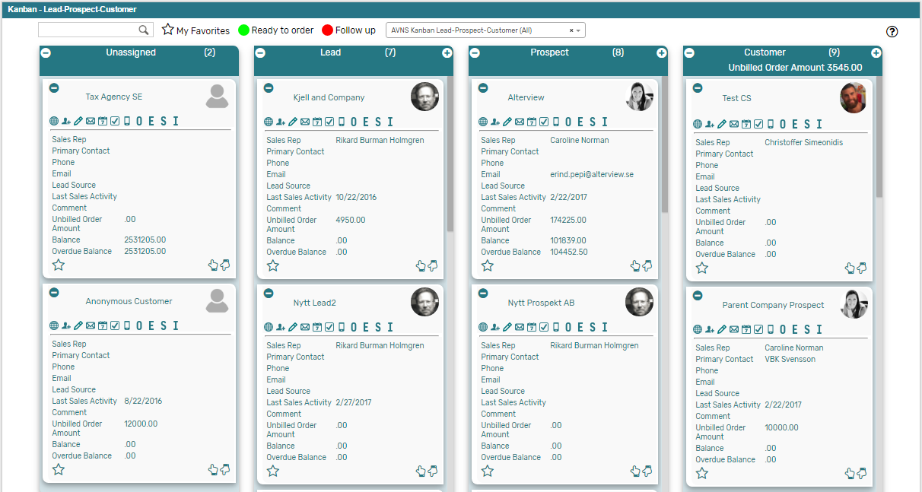

### Kanban – Lead-Prospect-Customer: Prerequisites

Before using the *Kanban – Lead-Prospect-Customer* board, please make sure the prerequisites listed below are fulfilled in order for the board to function as expected.

1. **Customer Status**  
   Moving cards between columns in the prebuilt *Kanban – Lead-Prospect-Customer* board will update the status of the record in the Kanban card to one of the NetSuite standard Customer status. Therefore, it is important that the statuses referred to in the board are available in your NetSuite account.   
     
   Navigate to Setup 🡪 Sales 🡪 Customer Statuses (Administrator) to find the list of Customer Statuses available in your NetSuite account. Compare the list from your NetSuite account with the Customer Status list which the prebuilt *Kanban – Lead-Prospect-Customer* refer to (picture below).   
     
   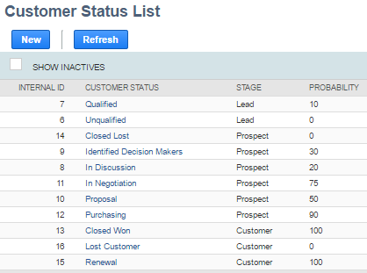  
     
   If the Customer Statuses differ between your NetSuite account and the picture above, you will need to edit the settings of the Kanban Columns for the *Kanban – Lead-Prospect-Customer* board.  
   ***Please refer to the section ‘Kanban Columns’ in the ‘Kanban User Guide’***
2. **Sales Rep & Sales Rep Image**  
   Make sure to mark the checkbox ‘Sales Rep’ on the Employee record for all available Sales Reps. *If Sales Team is activated in your account, please refer to Sales Team Configuration.*  
   If an image has been uploaded to the *Image* field on the Employee record, this image will be displayed on the Kanban card. If no image is available, a predefined profile icon will be displayed instead.
3. **Report 360**The *Kanban – Lead-Prospect-Customer* board includes the *Customer 360* PDF-report, built with native SuiteApp Report 360. To enable the *Customer 360* report, the SuiteApp Report 360 (bundle 106006) and Report 360 Prebuilt reports (bundle 120140) are required. Make sure to install both bundles in order to display the *Customer 360* report.

### Kanban – Lead-Prospect-Customer: Card Moves & Column Actions

The *Kanban – Lead-Prospect-Customer* board contains four Kanban Columns. Each column has been configured with one or several Column Actions. Double clicking on any card in the *Kanban – Lead-Prospect-Customer* board will open the entity record in edit mode.

1. **Unassigned**
   1. *Card Moves* – Kanban cards in the column *Unassigned* can be moved to all other columns in the Kanban board.
   2. *Column Actions* – when moving a Kanban card to the column *Unassigned* the Sales Rep field will be emptied and the entity will become unassigned.
2. **Lead**
   1. *Card Moves* – Kanban cards in the column *Lead* can be moved to all other columns in the Kanban board.
   2. *Column Actions* – when moving a Kanban card to the column *Lead* the status of the record represented in the Kanban card will be updated to *LEAD* – *Qualified* and the Sales Rep will be set to *@MySELF@* (Current User).
   3. *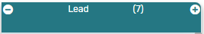Add Card* – it is possible to add a Kanban card (a new record) from the column *Lead* by clicking on the + icon in the top right corner of the column.
3. **Prospect**
   1. *Card Moves* – Kanban cards in the column *Prospect* can be moved to all other columns in the Kanban board.
   2. *Column Actions* – when moving a Kanban card to the column *Prospect* the status of the record represented in the Kanban card will be updated to *PROSPECT* – *In Discussion* and the Sales Rep will be set to *@MySELF@* (Current User).
   3. *Add Card* – it is possible to add a Kanban card (a new record) from the column *Prospect* by clicking on the + icon in the top right corner of the column.
4. **Customer**
   1. *Card Moves* – Kanban cards in the column *Customer* can be moved to all other columns in the Kanban board.
   2. *Column Actions* – when moving a Kanban card to the column *Customer* the status of the record represented in the Kanban card will be updated to *CUSTOMER* – *Closed* *Won*.
   3. 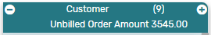*Add Card* – it is possible to add a Kanban card (a new record) from the column *Customer* by clicking on the + icon in the top right corner of the column.
   4.  *Column Aggregation –* there is a column aggregation in the *Customer* column, which calculates the sum of all unbilled orders for the records in the column to display the amount in the column header section.

### Kanban – Lead-Prospect-Customer: Available Card Actions

The Kanban cards in the *Kanban – Lead-Prospect-Customer* board each contains eleven Card Actions.

1. **View Customer 360**  
   View a customer 360 report of the entity from the Kanban card.
2. 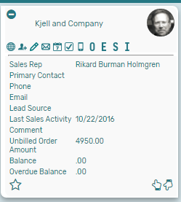**Customer: New Contact**Add a new contact to the customer from the Kanban card.
3. **Customer: New Note**Add a new note to the customer from the Kanban card.
4. **Customer: New Email**Add a new email to the customer from the Kanban card.
5. **Customer: New Event**Add a new event to the customer from the Kanban card.
6. **Customer: New Task**Add a new task to the customer from the Kanban card.
7. **Customer: New Phone Call**Add a new phone call to the customer from the Kanban card.
8. **Customer: New Opportunity**Add a new opportunity to the customer from the Kanban card.
9. **Customer: New Estimate**Add a new estimate to the customer from the Kanban card.
10. **Customer: New Sales Order**Add a new sales order to the customer from the Kanban card.
11. **Customer: New Invoice**Add a new invoice to the customer from the Kanban card.

### Kanban – Leads-Prospect-Customer Alternative Searches

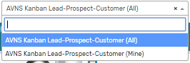There are two alternative searches for the *Kanban – Lead-Prospect-Customer* board.

1. **AVNS Kanban Lead-Prospect-Customer (All)**This search will display all registered leads in the *Kanban – Lead-Prospect-Customer* board.
2. **AVNS Kanban Lead-Prospect-Customer (Mine)**This search will display registered prospects where Sales Rep is *Mine* (current user) in the *Kanban – Lead-Prospect-Customer* board.

### Kanban – Lead-Prospect-Customer: Available Colors

There are two colors available for the *Kanban – Lead-Prospect-Customer* board, which can be used to highlight and filter the Kanban cards (*Ready to order // Follow up*). These are defined in the *Color* subtab of the Kanban configuration record.

# Kanban – Leads

The prebuilt *Kanban – Leads* provides an overview of registered leads in your NetSuite account, with each Kanban column representing a lead status. The last two Kanban columns represents leads converted to prospects and records with the status *PROSPECT – Closed Lost* modified within the last month.

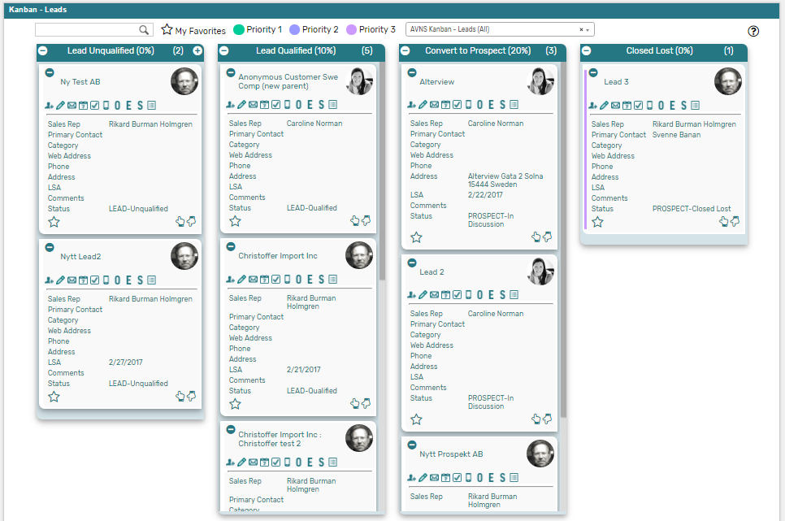

### Kanban – Leads: Prerequisites

Before using the *Kanban – Leads* board, please make sure the prerequisites listed below are fulfilled in order for the board to function as expected.

1. **Customer Status**  
   Since the columns of the prebuilt *Kanban – Leads* board are based on NetSuite standard Customer status, it is important that the statuses presented in the board are available in your NetSuite account.   
     
   Navigate to Setup 🡪 Sales 🡪 Customer Statuses (Administrator) to find the list of Customer Statuses available in your NetSuite account. Compare the list from your NetSuite account with the Customer Status list which the prebuilt *Kanban – Leads* board is based on (picture below).   
     
     
     
   If the Customer Statuses differ between your NetSuite account and the picture above, you will need to edit the settings of the Kanban Columns for the *Kanban – Leads* board.  
   ***Please refer to the section ‘Kanban Columns’ in the ‘Kanban User Guide’***
2. **Sales Rep & Sales Rep Image**  
   Make sure to mark the checkbox ‘Sales Rep’ on the Employee record for all available Sales Reps.   
   If an image has been uploaded to the *Image* field on the Employee record, this image will be displayed on the Kanban card. If no image is available, a predefined profile icon will be displayed instead.

### 

### Kanban – Leads: Card Moves & Column Actions

The *Kanban – Leads* board contains four Kanban Columns. Each column has been configured with one or several Column Actions. Double clicking on any card in the *Kanban – Leads* board will open the lead record in edit mode.



1. **Lead Unqualified (0%)**
   1. *Card Moves* – Kanban cards in the column *Lead Unqualified (0%)* can be moved to all other columns in the Kanban board.
   2. *Column Actions* – when moving a Kanban card to the column *Lead Unqualified (0%)* the status of the record represented in the Kanban card will be updated to *LEAD* – *Unqualified* and the Sales Rep will be set to *@MySELF@* (Current User).
   3. *Add Card* – it is possible to add a Kanban card (a new record) from the column *Lead Unqualified (0%)* by clicking on the + icon in the top right corner of the column.



1. **Lead Qualified (10%)**
   1. *Card Moves* – Kanban cards in the column *Lead Qualified (10%)* can be moved to all other columns in the Kanban board.
   2. *Column Actions* – when moving a Kanban card to the column *Lead Qualified (10%)* the status of the record represented in the Kanban card will be updated to *LEAD* – *Qualified* and the Sales Rep will be set to *@MySELF@* (Current User).
2. **Convert to Prospect (20%)**
   1. *Card Moves* – Kanban cards in the column *Convert to Prospect (20%)* can be moved to all other columns in the Kanban board.
   2. *Column Actions* – when moving a Kanban card to the column *Convert to Prospect (20%)* the status of the record represented in the Kanban card will be updated to *PROSPECT* – *In Discussion* and the Sales Rep will be set to *@MySELF@* (Current User).
3. **Closed Lost (0%)**
   1. *Card Moves* – Kanban cards in the column *Closed Lost (0%)* can be moved to all other columns in the Kanban board.
   2. *Column Actions* – when moving a Kanban card to the column *Closed Lost (0%)* the status of the record represented in the Kanban card will be updated to *PROSPECT* – *Closed* *Lost*.

Kanban – Leads: Available Card Actions

The Kanban cards in the *Kanban – Leads* board each contains ten Card Actions.

1. 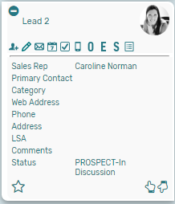**Lead: New Contact**Add a new contact to the lead from the Kanban card.
2. **Lead: New Note**Add a new note to the lead from the Kanban card.
3. **Lead: New Email**Add a new email to the lead from the Kanban card.
4. **Lead: New Event**Add a new event to the lead from the Kanban card.
5. **Lead: New Task**Add a new task to the lead from the Kanban card.
6. **Lead: New Phone Call**Add a new phone call to the lead from the Kanban card.
7. **Lead: New Opportunity**Add a new opportunity to the lead from the Kanban card.
8. **Lead: New Estimate**Add a new estimate to the lead from the Kanban card.
9. **Lead: New Sales Order**Add a new sales order to the lead from the Kanban card.
10. **Lead: Show Activity**Show a list of all activities related to the lead from the Kanban card.

### Kanban – Leads: Alternative Searches

There are three alternative searches for the *Kanban – Leads* board.

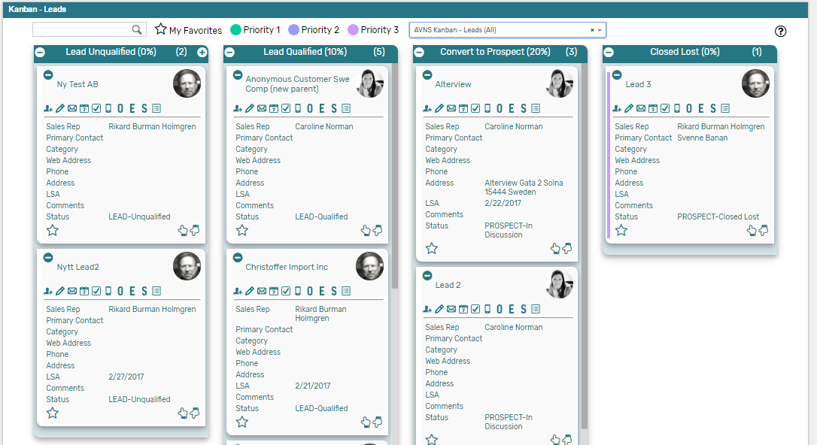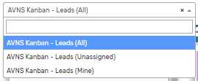

1. **AVNS Kanban Leads (All)**This search will display all registered leads in the *Kanban – Leads* board.
2. **AVNS Kanban Leads (Mine)**This search will display registered prospects where Sales Rep is *Mine* (current user) in the *Kanban – Leads* board.
3. **AVNS Kanban Leads (Unassigned)**This search will display registered prospects without an assigned Sales Rep in the *Kanban – Leads* board.

### Kanban – Leads: Available Colors

There are three colors available for the *Kanban – Leads* board, which can be used to highlight and filter the Kanban cards (*Priority 1 // Priority 2 // Priority 3*). These are defined in the *Color* subtab of the Kanban configuration record.

# Kanban – Prospect

The prebuilt *Kanban – Prospect* provides an overview of registered prospects in your NetSuite account, with each Kanban column representing a prospect status. The last column contains two Kanban columns, stacked on top of each other, one representing prospect converted to customers and the other one records with the status *PROSPECT – Closed Lost* modified within the last month.

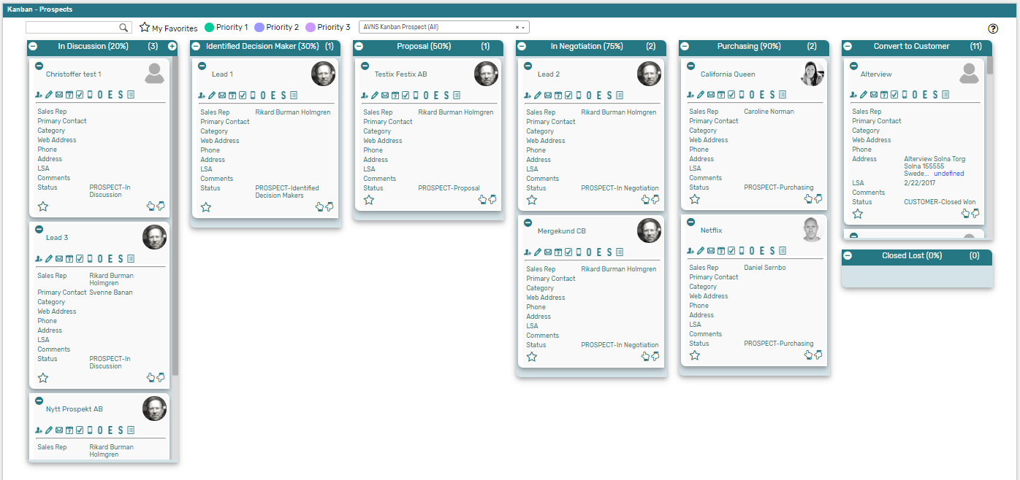

### Kanban – Prospects: Prerequisites

Before using the *Kanban – Prospect* board, please make sure the prerequisites listed below are fulfilled in order for the board to function as expected.

1. **Customer Status**  
   Since the columns of the prebuilt *Kanban – Prospect* board are based on NetSuite standard Customer status, it is important that the statuses presented in the board are available in your NetSuite account.   
     
   Navigate to Setup 🡪 Sales 🡪 Customer Statuses (Administrator) to find the list of Customer Statuses available in your NetSuite account. Compare the list from your NetSuite account with the Customer Status list which the prebuilt *Kanban – Prospect* board is based on (picture below).   
     
     
     
   If the Customer Statuses differ between your NetSuite account and the picture above, you will need to edit the settings of the Kanban Columns for the *Kanban – Prospect* board.  
   ***Please refer to the section ‘Kanban Columns’ in the ‘Kanban User Guide’***
2. **Sales Rep & Sales Rep Image**  
   Make sure to mark the checkbox ‘Sales Rep’ on the Employee record for all available Sales Reps.   
   If an image has been uploaded to the *Image* field on the Employee record, this image will be displayed on the Kanban card. If no image is available, a predefined profile icon will be displayed instead.

### 

### Kanban – Prospects: Card Moves & Column Actions

The *Kanban – Prospect* board contains six Kanban Columns. Each column has been configured with one or several Column Actions. Double clicking on any card in the *Kanban – Prospect* board will open the prospect record in edit mode.  


1. **In Discussion (20%)**
   1. *Card Moves* – Kanban cards in the column *In Discussion (20%)* can be moved to all other columns in the Kanban board.
   2. *Column Actions* – when moving a Kanban card to the column *In Discussion (20%)* the status of the record represented in the Kanban card will be updated to *PROSPECT* – *In Discussion* and the Sales Rep will be set to *@MySELF@* (Current User).
   3. *Add Card* – it is possible to add a Kanban card (a new record) from the column *In Discussion (20%)* by clicking on the + icon in the top right corner of the column.   
        
      
2. **Identified Decision Makers (30%)**
   1. *Card Moves* – Kanban cards in the column *Identified Decision Makers (30%)* can be moved to all other columns in the Kanban board.
   2. *Column Actions* – when moving a Kanban card to the column *Identified Decision Makers (30%)* the status of the record represented in the Kanban card will be updated to *PROSPECT* – *Identified Decision Makers* and the Sales Rep will be set to *@MySELF@* (Current User).
3. **Proposal (50%)**
   1. *Card Moves* – Kanban cards in the column *Proposal (50%)* can be moved to all other columns in the Kanban board.
   2. *Column Actions* – when moving a Kanban card to the column *Proposal (50%)* the status of the record represented in the Kanban card will be updated to *PROSPECT* – *In Discussion* and the Sales Rep will be set to *@MySELF@* (Current User).
4. **In Negotiation (75%)**
   1. *Card Moves* – Kanban cards in the column *In Negotiation (75%)* can be moved to all other columns in the Kanban board.
   2. *Column Actions* – when moving a Kanban card to the column *In Negotiation (75%)* the status of the record represented in the Kanban card will be updated to *PROSPECT* – *In Discussion* and the Sales Rep will be set to *@MySELF@* (Current User).
5. **Purchasing (90%)**
   1. *Card Moves* – Kanban cards in the column *Purchasing (90%)* can be moved to all other columns in the Kanban board.
   2. *Column Actions* – when moving a Kanban card to the column *Purchasing (90%)* the status of the record represented in the Kanban card will be updated to *PROSPECT* – *In Discussion* and the Sales Rep will be set to *@MySELF@* (Current User).
6. **Converted to Customer**
   1. *Card Moves* – Kanban cards in the column *Converted to Customer* can be moved to all other columns in the Kanban board.
   2. *Column Actions* – when moving a Kanban card to the column *Converted to Customer* the status of the record represented in the Kanban card will be updated to *CUSTOMER – Closed Won* and the Sales Rep will be set to *@MySELF@* (Current User).
7. **Closed Lost (0%)**
   1. *Card Moves* – Kanban cards in the column *Closed Lost (0%)* can be moved to all other columns in the Kanban board.
   2. *Column Actions* – when moving a Kanban card to the column *Closed Lost (0%)* the status of the record represented in the Kanban card will be updated to *PROSPECT* – *Closed* Lostand the Sales Rep will be set to *@MySELF@* (Current User).

### Kanban – Prospects: Available Card Actions

The Kanban cards in the *Kanban – Prospect* board each contains ten Card Actions.

1. **Prospect: New Contact**Add a new contact to the prospect from the Kanban card.

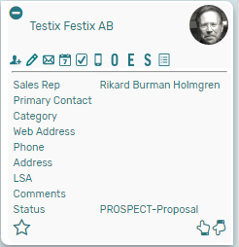

1. **Prospect: New Note**Add a new note to the prospect from the Kanban card.
2. **Prospect: New Email**Add a new email to the prospect from the Kanban card.
3. **Prospect: New Event**Add a new event to the prospect from the Kanban card.
4. **Prospect: New Task**Add a new task to the prospect from the Kanban card.
5. **Prospect: New Phone Call**Add a new phone call to the prospect from the Kanban card.
6. **Prospect: New Opportunity**Add a new opportunity to the prospect from the Kanban card.
7. **Prospect: New Estimate**Add a new estimate to the prospect from the Kanban card.
8. **Prospect: New Sales Order**Add a new sales order to the prospect from the Kanban card.
9. **Prospect: Show Activity**Show a list of all activities related to the prospect from the Kanban card.

### Kanban – Prospects: Alternative Searches

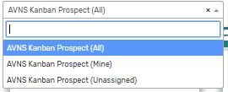There are three alternative searches for the *Kanban – Prospect* board.  
  
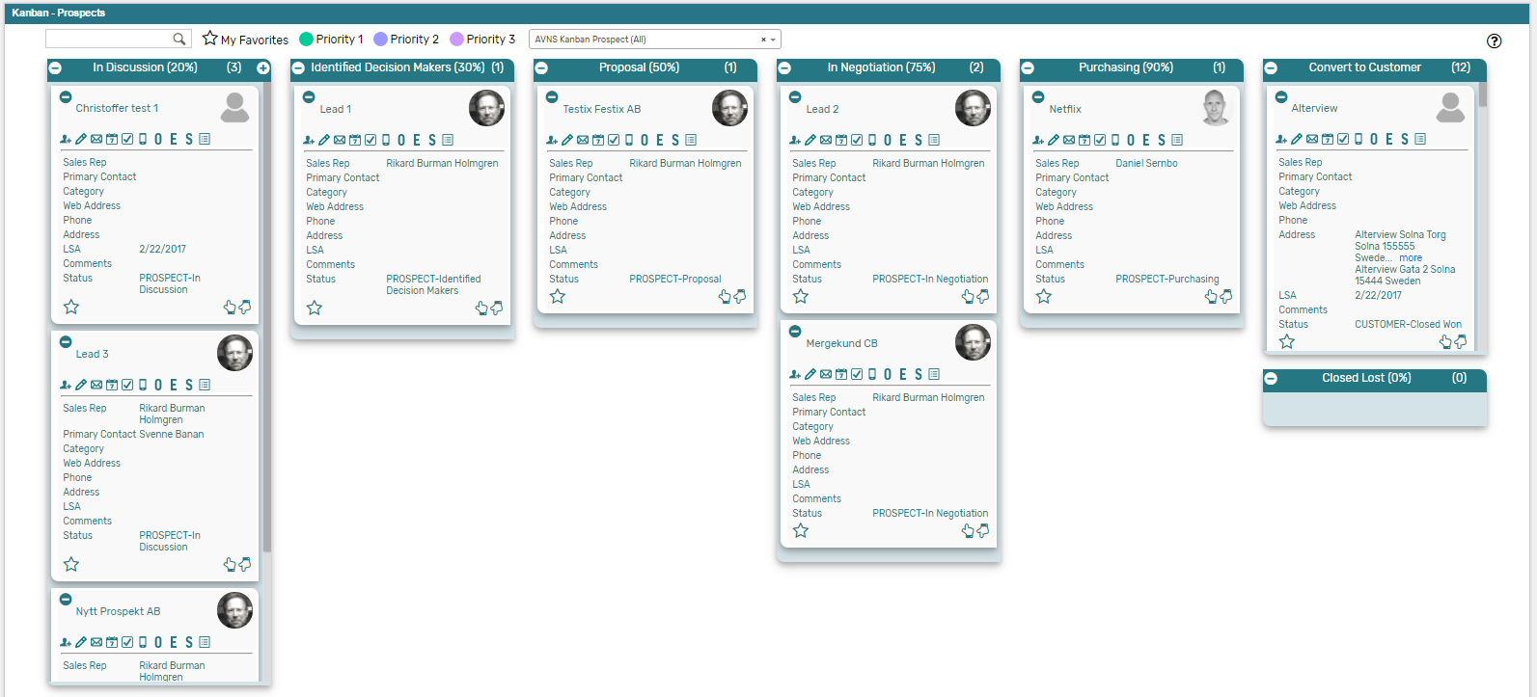

1. **AVNS Kanban Prospect (All)**This search will display all registered prospects in the *Kanban – Prospects* board.
2. **AVNS Kanban Prospect (Mine)**This search will display registered prospects where Sales Rep is *Mine* (current user) in the *Kanban – Prospects* board.
3. **AVNS Kanban Prospect (Unassigned)**This search will display registered prospects without an assigned Sales Rep in the *Kanban – Prospects* board.

### Kanban – Prospects: Available Colors

There are three colors available for the *Kanban – Prospect* board, which can be used to highlight and filter the Kanban cards (*Priority 1 // Priority 2 // Priority 3*). These are defined in the *Color* subtab of the Kanban configuration record.   
  


# Kanban – Customer LSA

The prebuilt *Kanban – Customer LSA* provides an overview of last sales activity (LSA) with registered customers in your NetSuite account. Each Kanban column represents a time period for when last sales activity occurred.  
  
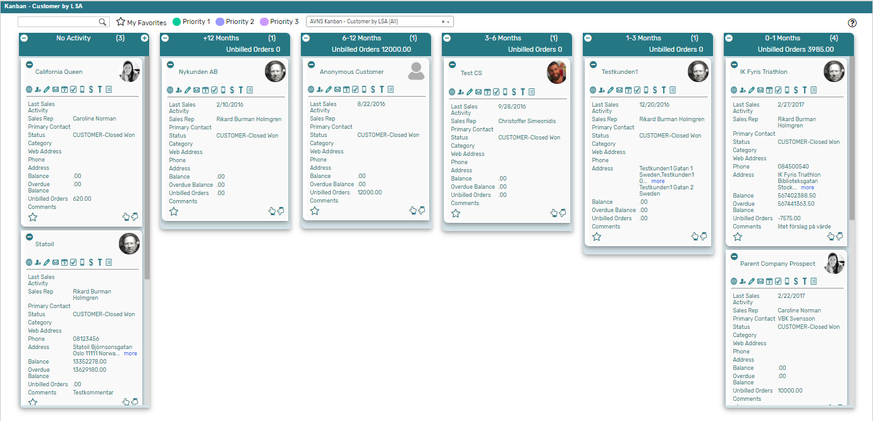

### Kanban – Customer by LSA: Prerequisites

Before using the *Kanban – Customer by LSA* board, please make sure the prerequisites listed below are fulfilled in order for the board to function as expected.

1. 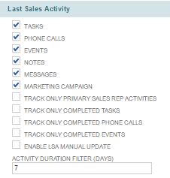**Last Sales Activity**  
   Since the columns of the prebuilt *Kanban – Customer by LSA* board are based on Last Sales Activity (LSA), it is important that this feature is enabled in your NetSuite account. For all new NetSuite account the LSA functionality is enabled by default, in older NetSuite accounts the functionality can by enabled by installing the Last Sales Activity bundle from NetSuite (bundle 53195).  
     
   Which activities to include to Last Sales Activity is defined per NetSuite account. Navigate to Setup 🡪 Company 🡪 General Preferences and the subtab *Custom Preferences* (Administrator) to define the preferences for the NetSuite account.
2. **Customer Status**  
   When adding a card to the first column of the prebuilt *Kanban – Customer by LSA* board, the customer status of the record will be set to a NetSuite standard Customer status. Therefore, it is important that the statuses referred to in the board are available in your NetSuite account.   
     
   Navigate to Setup 🡪 Sales 🡪 Customer Statuses (Administrator) to find the list of Customer Statuses available in your NetSuite account. Compare the list from your NetSuite account with the Customer Status list which the prebuilt *Kanban – Customer by LSA* board is based on (picture below).   
     
   If the Customer Statuses differ between your NetSuite account and the picture above, you will need to edit the settings of the Kanban Columns for the *Kanban – Customer by LSA* board.  
   ***Please refer to the section ‘Kanban Columns’ in the ‘Kanban User Guide’***
3. **Sales Rep & Sales Rep Image**  
   Make sure to mark the checkbox ‘Sales Rep’ on the Employee record for all available Sales Reps.   
   If an image has been uploaded to the *Image* field on the Employee record, this image will be displayed on the Kanban card. If no image is available, a predefined profile icon will be displayed instead.
4. **Report 360**The *Kanban – Customer by LSA* board includes the *Customer 360* PDF-report, built with native SuiteApp Report 360. To enable the *Customer 360* report, the SuiteApp Report 360 (bundle 106006) and Report 360 Prebuilt reports (bundle 120140) are required. Make sure to install both bundles in order to display the *Customer 360* report.

Kanban – Customer by LSA: Card Moves & Column Actions

The *Kanban – Customer by LSA* board contains six Kanban Columns, based on Last Sales Activity. This Kanban function differently from other Kanban boards, as the cards can only be moved via Card Actions and not through drag and drop. Only the first column is configured with a Column Actions. Double clicking on any card in the *Kanban – Customers by LSA* board will open the customer record in edit mode.



1. **No Activity***Customer records with no activities registered as Last Sales Activity.*
   1. *Card Moves* – None, only via Kanban Card Actions.
   2. *Column Actions* – when adding a Kanban card to the column the status of the record represented in the Kanban card will be updated to *CUSTOMER* – *Closed Won*.
   3. *Add Card* – it is possible to add a Kanban card (a new record) from the column *No Activity* by clicking on the + icon in the top right corner of the column.
2. **+12 Months***Customer records with activities registered as Last Sales Activity over 12 months ago.*
   1. *Card Moves* – None, only via Kanban Card Actions.
   2. *Column Aggregation* *–* the column aggregation in the *+12 Months* column calculates the sum of all unbilled orders for the records in the column, to display the amount in the column header section.
3. **6-12 Months**

*Customer records with activities registered as Last Sales Activity between 6-12 months ago.*

* 1. *Card Moves* – None, only via Kanban Card Actions.
  2. *Column Aggregation* *–* the column aggregation in the *6-12 Months* column calculates the sum of all unbilled orders for the records in the column, to display the amount in the column header section.

1. **3-6 Months**

*Customer records with activities registered as Last Sales Activity between 3-6 months ago.*

* 1. *Card Moves* – None, only via Kanban Card Actions.
  2. *Column Aggregation* *–* the column aggregation in the *3-6 Months* column calculates the sum of all unbilled orders for the records in the column, to display the amount in the column header section.

1. **1-3 Months**

*Customer records with activities registered as Last Sales Activity between 1-3 months ago.*

* 1. *Card Moves* – None, only via Kanban Card Actions.
  2. *Column Aggregation* *–* the column aggregation in the *1-3 Months* column calculates the sum of all unbilled orders for the records in the column, to display the amount in the column header section.

1. **0-1 Months**

*Customer records with activities registered as Last Sales Activity within the last month.*

* 1. *Card Moves* – None, only via Kanban Card Actions.
  2. *Column Aggregation* *–* the column aggregation in the *0-1 Months* column calculates the sum of all unbilled orders for the records in the column, to display the amount in the column header section.   
       
     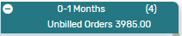

### Kanban – Customer by LSA: Available Card Actions

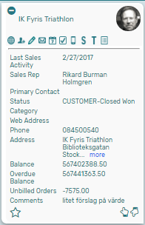The Kanban cards in the *Kanban – Customer by LSA* board each contains ten Card Actions. Card actions regarding activities will update the Last Sales Activity field, making the card move to the appropriate column in the *Kanban – Customer by LSA* board.

1. **Customer: View Customer 360**  
   View a Customer 360 report of the customer from the Kanban card.
2. **Customer: New Contact**Add a new contact to the customer from the Kanban card.
3. **Customer: New Note**Add a new note to the customer from the Kanban card.
4. **Customer: New Email**Add a new email to the customer from the Kanban card.
5. **Customer: New Event**Add a new event to the customer from the Kanban card.
6. **Customer: New Task**Add a new task to the customer from the Kanban card.
7. **Customer: New Phone Call**Add a new phone call to the customer from the Kanban card.
8. **Customer: New Sales Order**Add a new sales order to the customer from the Kanban card.
9. **Customer: Show Transactions**Show a list of all transactions related to the customer from the Kanban card.
10. **Customer: Show Activity**Show a list of all activities related to the customer from the Kanban card.

### Kanban – Customer by LSA: Alternative Searches

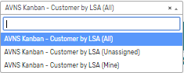There are three alternative searches for the *Kanban – Customer by LSA* board.

1. **AVNS Kanban Customer by LSA (All)**This search will display all registered customers in the *Kanban – Customer by LSA* board.
2. **AVNS Kanban Customer by LSA (Mine)**This search will display registered customers where Sales Rep is *Mine* (current user) in the *Kanban – Customer by LSA* board.
3. **AVNS Kanban Customer by LSA (Unassigned)**This search will display registered customers without an assigned Sales Rep in the *Kanban – Customer by LSA* board.

### Kanban – Customer by LSA: Available Colors

There are three colors available for the *Kanban – Customer by LSA* board, which can be used to highlight and filter the Kanban cards (*Priority 1 // Priority 2 // Priority 3*). These are defined in the *Color* subtab of the Kanban configuration record.

# Kanban – Inside sales

The prebuilt *Kanban – Inside Sales* gives the user an extremely good overview of all scheduled phone calls, with each Kanban column representing when the phone call is scheduled. The last column represents phone calls that have been completed within the last week.

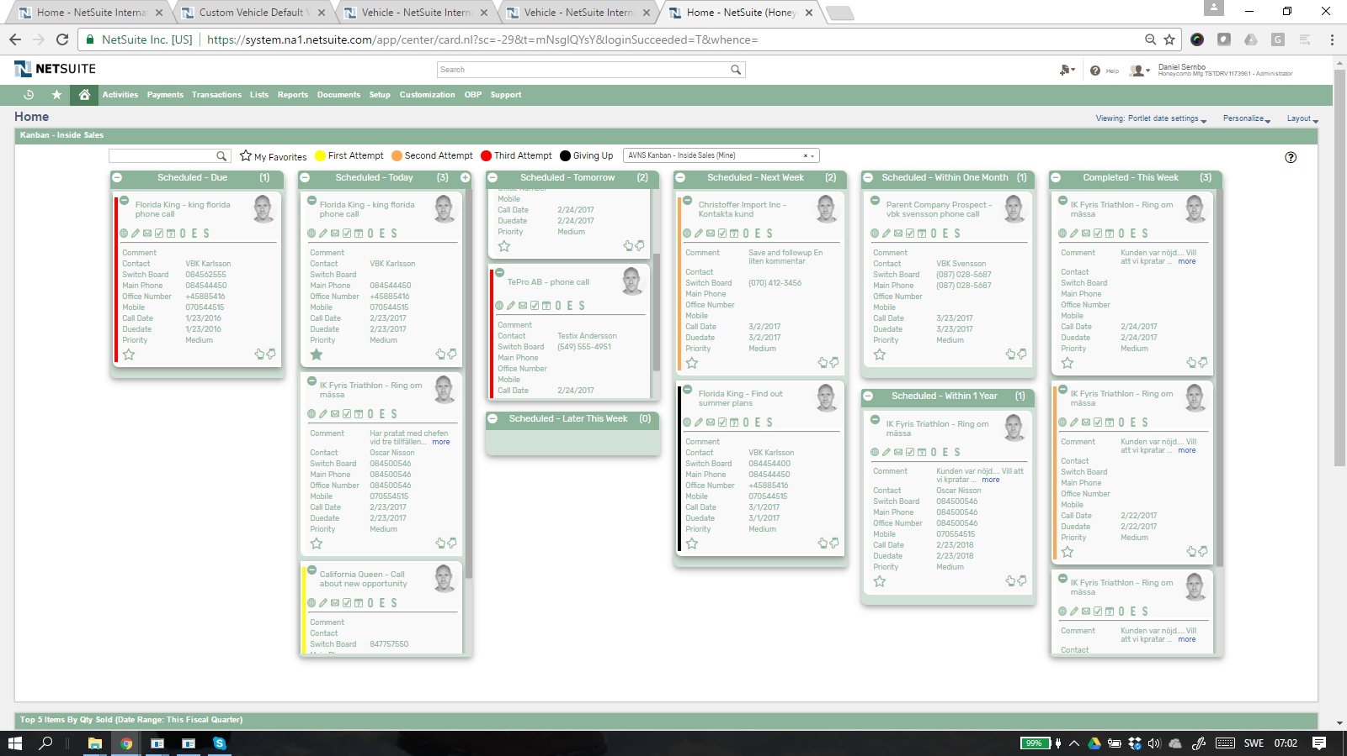

### Kanban – Inside Sales: Prerequisites

Before using the *Kanban – Inside Sales*, please make sure the prerequisites listed below are fulfilled in order for the board to function as expected.

1. **Employee Image**  
   Make sure to uploaded an *Image* field on each Employee record, this image will be displayed on the Kanban card if the employee is assigned to the phone call. If no image is available, a predefined profile icon will be displayed instead.
2. **Customer 360**  
   The Kanban – Inside Sales board includes the Customer 360 PDF-report, built with native SuiteApp Report 360. To enable the Customer 360 report, the  
   SuiteApp Report 360 (bundle 106006) and Report 360 Prebuilt reports (bundle 120140) are required. Make sure to install both bundles in order to display the Customer 360 report.

### 

### Kanban – Inside Sales: Card Moves & Column Actions

The *Kanban – Inside Sales* board contains eight Kanban Columns. Each column has been configured with one or several Column Actions. Double clicking on any card in the *Kanban – Inside Sales* board will open the phone call record in edit mode.  


1. **Scheduled - Due**
   1. *Card Moves* – Kanban cards in the column *Scheduled - Due* can be moved to all other columns in the Kanban board. It is not allowed to move a card to this column. All phone calls that are due will automatically end up in this column.
2. **Scheduled - Today**
   1. *Card Moves* – Kanban cards in the column *Scheduled - Today* can be moved to all other columns in the Kanban board besides Scheduled - Due.
   2. *Column Actions* – when moving a Kanban card to the column *Scheduled – Today,* the Call Date field will be updated and set to today.
   3. *Add Card* – Is only available in this column. It opens a new phone call that by default is scheduled today and assigned to the user. 
3. **Scheduled - Tomorrow**
   1. *Card Moves* – Kanban cards in the column *Scheduled - Tomorrow* can be moved to all other columns in the Kanban board besides Scheduled - Due.
   2. *Column Actions* – when moving a Kanban card to the column *Scheduled – Tomorrow,* the Call Date field will be updated and set to tomorrow.
4. **Scheduled – Later this Week**
   1. *Card Moves* – Kanban cards in the column *Scheduled – Later this Week* can be moved to all other columns in the Kanban board besides Scheduled - Due**.**
   2. *Column Actions* – when moving a Kanban card to the column *Scheduled – Later this Week,* the Call Date field will be updated and set to Friday this week.
5. **Scheduled – Next Week**
6. *Card Moves* – Kanban cards in the column *Scheduled – Next Week* can be moved to all other columns in the Kanban board besides Scheduled - Due.
7. *Column Actions* – when moving a Kanban card to the column *Scheduled – Next Week,* the Call Date field will be updated and set to 7 days from today.
8. **Scheduled – Within One Month**
9. *Card Moves* – Kanban cards in the column *Scheduled – Within One Month* can be moved to all other columns in the Kanban board besides Scheduled - Due.
10. *Column Actions* – when moving a Kanban card to the column *Scheduled – Within One Month,* the Call Date field will be updated and set to 28 days from today (28 to make sure it is the same weekday).
11. **Scheduled – Within One Year**
12. *Card Moves* – Kanban cards in the column *Scheduled – Within One Year* can be moved to all other columns in the Kanban board besides Scheduled - Due.
13. *Column Actions* – when moving a Kanban card to the column *Scheduled – Within One Year,* the Call Date field will be updated and set to 364 days from today (364 to make sure it is the same weekday).
14. **Completed – This Week**
15. *Card Moves – Kanban cards in the column Completed – This Week can’t be moved. If you like to move a card from this column you have to open the phone call and edit status manually.*
16. *Column Actions – when moving a Kanban card to the column Completed – This week, the phone call status will be set to completed.****OBS!*** *Sometimes when you complete a phone call you like to follow up on this phone call later. Use standard NetSuite function, save and follow up (save & copy) This will create a new phone call that you manually can schedule. When you have saved this new phone call you will have to refresh the Kanban board before it appears.*

### Kanban – Inside Sales: Available Card Actions

The Kanban cards in the *Kanban – Inside Sales* board each contains nine Card Actions. 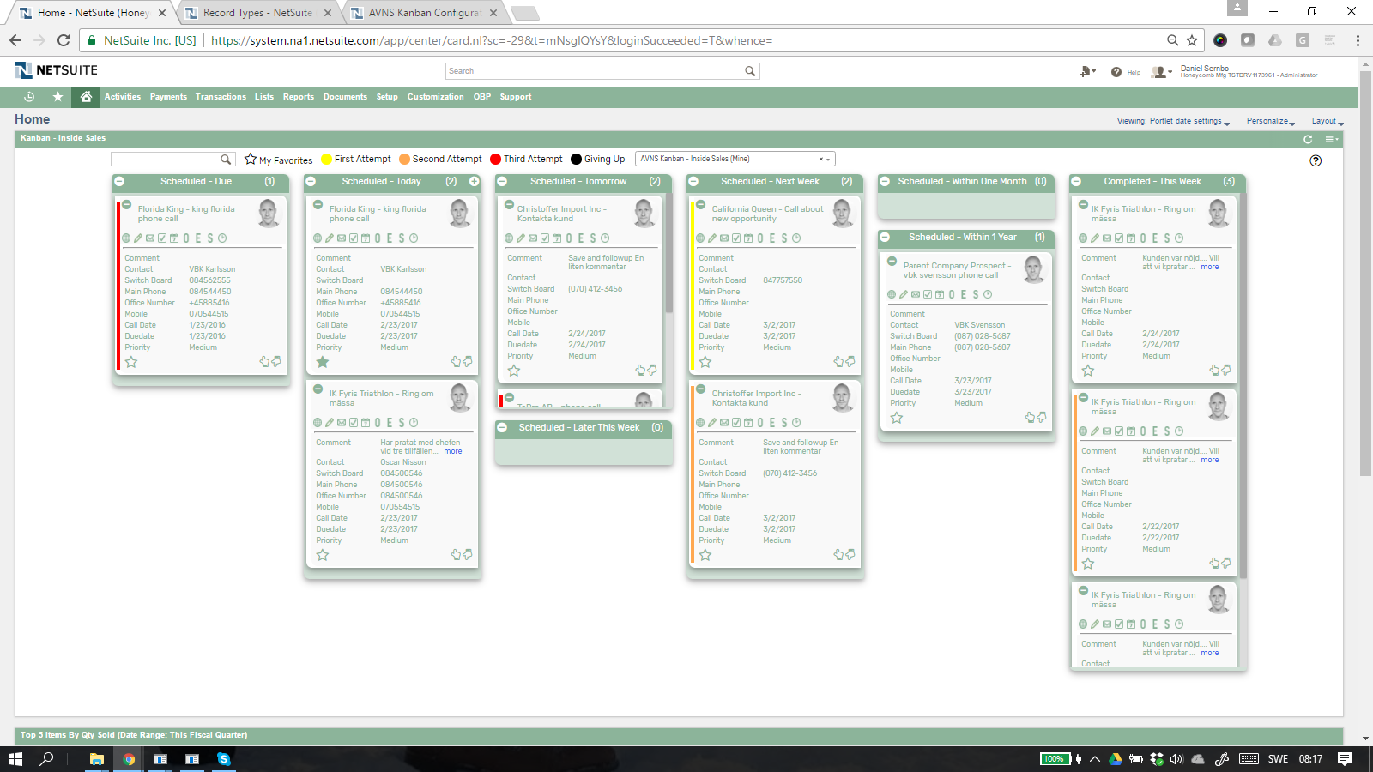

1. **Phone: View Customer 360**View Customer 360 report for current customer.
2. **Phone: New Note**Add a new note attached to the phone call.
3. **Phone: Send Email**Send a email to the customer contact from the Kanban card.
4. **Phone: New Task**Create a new task connected to the customer from the   
   Kanban card.
5. **Phone: New Event**Invite the customer contact to a new event from the   
   Kanban card.
6. **Phone: New Opportunity**Create a new opportunity to the customer from the Kanban   
   card.
7. **Phone: New Estimate**Create a new estimate to the customer from the Kanban card.
8. **Phone: New Sales Order**Create a new Sales Order to the customer from the Kanban card.
9. **Phone: New Time Entry**Create a new Time Entry for time you spent on the phone with the customer.

### Kanban – Inside Sales: Alternative Searches

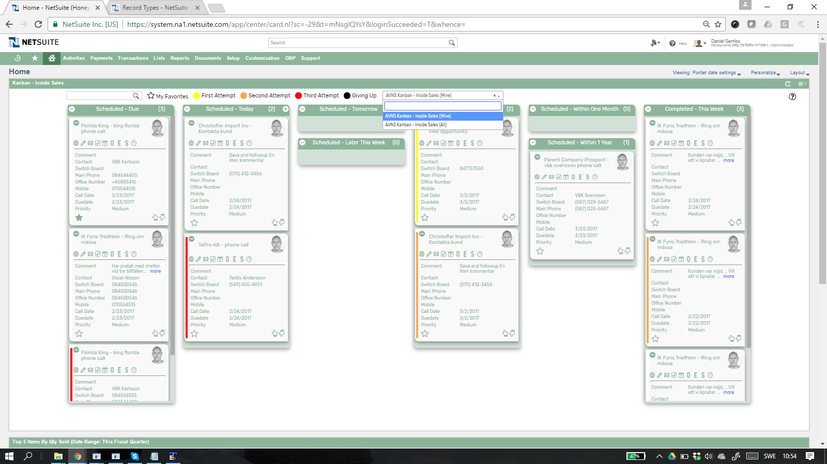There are two alternative searches for the *Kanban – Inside Sales* board.  


1. **AVNS Kanban – Inside Sales (All)**This search will display all registered Customer Phone Calls in the *Kanban – Inside Sales* board.
2. **AVNS Kanban – Inside Sales (Mine)**This search will display registered Customer Phone Calls assigned to current user in the *Kanban – Inside Sales* board.

### Kanban – Inside Sales: Available Colors

There are fore colors available for the *Kanban – Inside Sales* board, which can be used to highlight and filter the Kanban cards (First Attempt *// Second Attempt // Third Attempt // Giving Up*). These are defined in the *Color* subtab of the Kanban configuration record.   
  


# Kanban – Tasks by Status

The prebuilt *Kanban – Tasks by Status* provides quick overview of registered tasks in your NetSuite account, with each Kanban column representing a task status. The column *Completed* will only show task completed within this week.

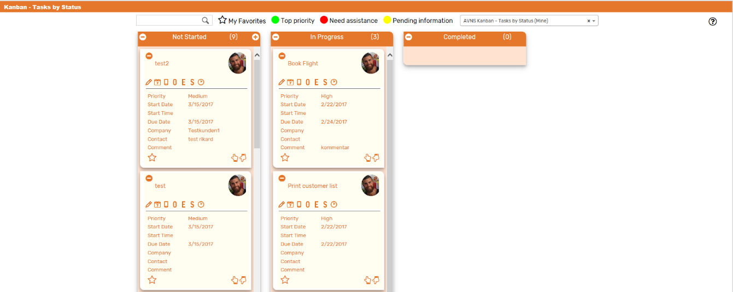  
  
Kanban – Tasks by Status: Prerequisites

Before using the *Kanban – Tasks by Status*, please make sure the prerequisites listed below are fulfilled in order for the board to function as expected.

1. **Sales Rep & Sales Rep Image**  
   Make sure to mark the checkbox ‘Sales Rep’ on the Employee record for all available Sales Reps.   
     
   If an image has been uploaded to the *Image* field on the Employee record, this image will be displayed on the Kanban card. If no image is available, a predefined profile icon will be displayed instead.

### Kanban – Tasks by Status: Card Moves & Column Actions

The *Kanban – Tasks by Status* board contains three Kanban Columns. Each column has been configured with one Column Action. Double clicking on any card in the *Kanban – Tasks by Status* board will open the task record in edit mode.

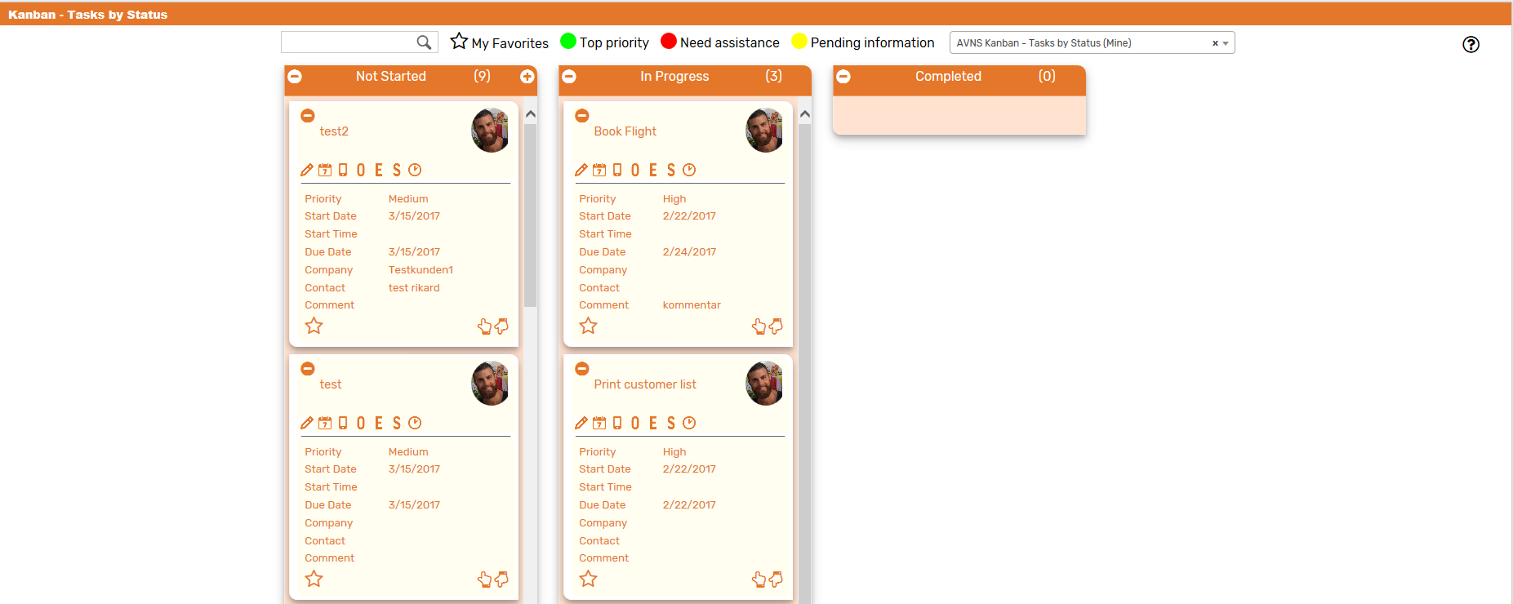

1. **Not Started**
   1. *Card Moves* – Kanban cards in the column *Not Started* can be moved to all other columns in the Kanban board.
   2. *Column Actions* – When moving a Kanban card to the column *Not Started* the status of the record represented in the Kanban card will be updated to *Not Started*.
2. **In Progress**
   1. *Card Moves* – Kanban cards in the column *Not Started* can be moved to all other columns in the Kanban board.
   2. *Column Actions* – When moving a Kanban card to the column *In Progress* the status of the record represented in the Kanban card will be updated to *In Progress*.
3. **Completed**
   1. *Card Moves* – Kanban cards in the column *Completed* can be moved to all other columns in the Kanban board.
   2. *Column Actions* – When moving a Kanban card to the column *Completed* the status of the record represented in the Kanban card will be updated to *Completed.*

### Kanban – Tasks by Status: Available Card Actions

The Kanban cards in the *Kanban – Tasks by Status* board each contains seven Card Actions.

1. 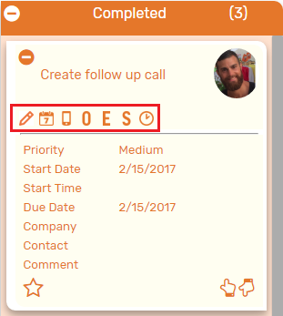**TASK: New Note**Add a new note to the task from the Kanban card.
2. **TASK: New Event**Create a new event from the Kanban card.
3. **TASK: New Phone Call**Create a new phone call from the Kanban card.
4. **TASK: New Opportunity**Create a new opportunity from the Kanban card.
5. **TASK: New Estimate**Create a new estimate from the Kanban card.
6. **TASK: New Sales Order**Create a new sales order from the Kanban card.
7. **TASK: Enter Time**Add a time tracking record to the task from the Kanban card.

### Kanban – Tasks by Status: Alternative Searches

There are two alternative searches for the *Kanban – Tasks by Status* board.

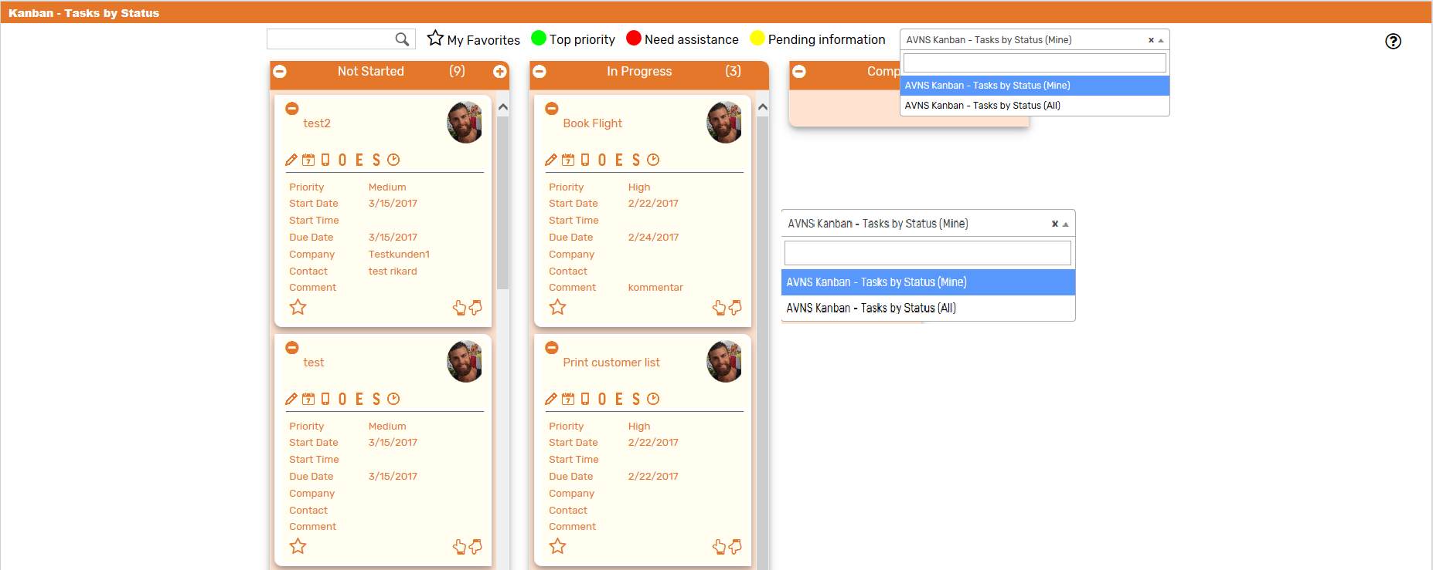

1. **AVNS Kanban – Tasks by Status (All)**This search will display all registered tasks in the *Kanban – Tasks by Status* board.
2. **AVNS Kanban – Tasks by Status (Mine)**This search will display registered tasks where assigned to is *Mine* (current user) in the *Kanban – Tasks by Status* board.

### Kanban – Tasks by Status: Available Colors

There are three colors available for the *Kanban – Tasks by Status* board, which can be used to highlight and filter the Kanban cards (*Top priority // Pending information // Need assistance*). These are defined in the *Color* subtab of the Kanban configuration record.

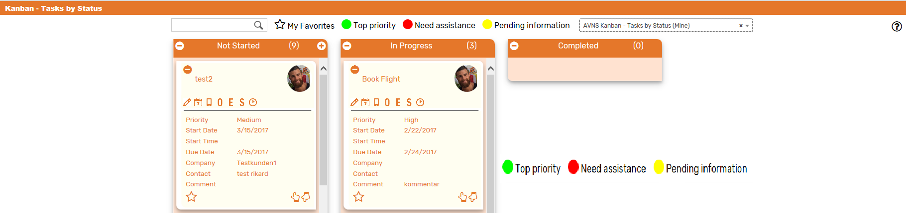

# Kanban – Tasks by Date

The prebuilt *Kanban – Tasks by Date* provides an overview of registered tasks in your NetSuite account, with each Kanban column representing a task status in relation to the task due date. The first column contains one Kanban column, Passed Due, showing all uncompleted tasks where due date is passed. Using this Kanban users can act on uncompleted tasks that either passed due date or due date is close. It also allows the tasks to be rescheduled to a later due date by simply drag the card to desired column.

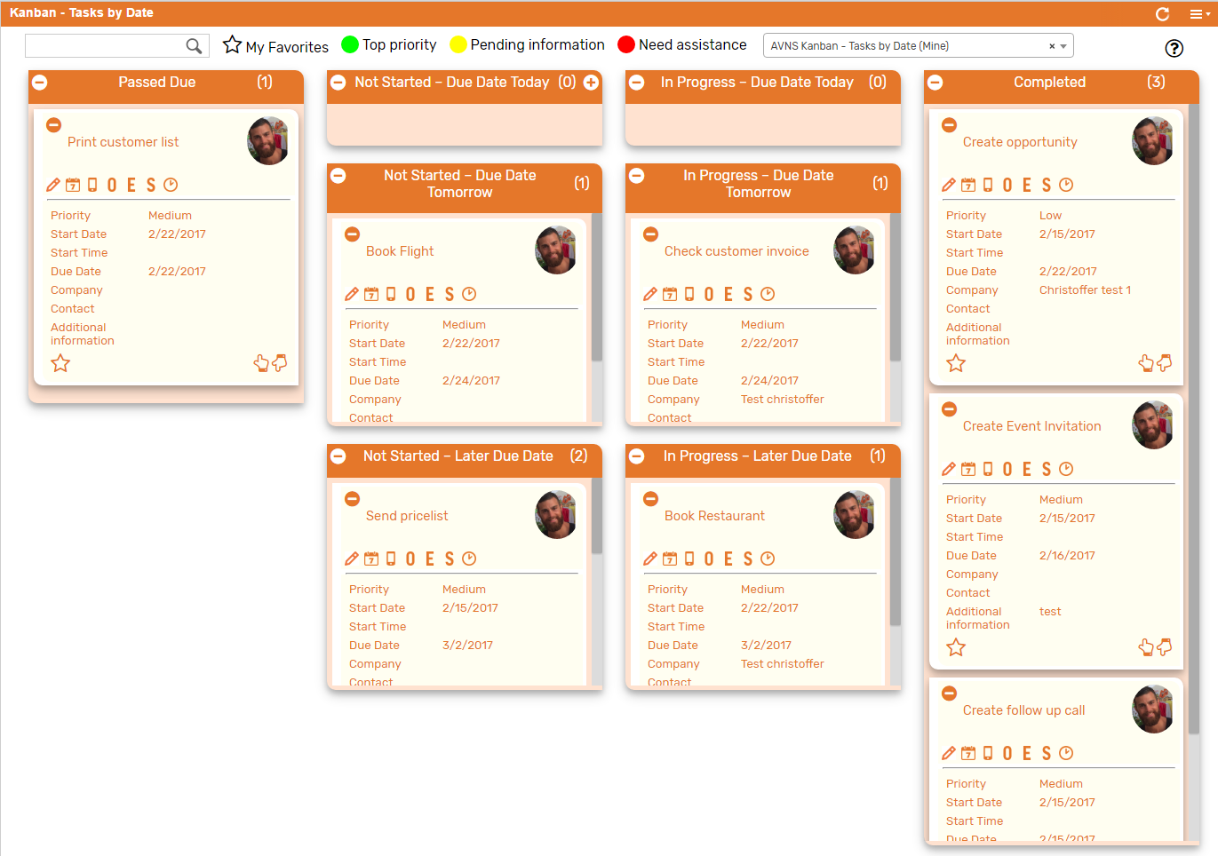  
  
Kanban – Tasks by Date: Prerequisites

Before using the *Kanban – Tasks by Date*, please make sure the prerequisites listed below are fulfilled in order for the board to function as expected.

1. **Sales Rep & Sales Rep Image**  
   Make sure to mark the checkbox ‘Sales Rep’ on the Employee record for all available Sales Reps.   
   If an image has been uploaded to the *Image* field on the Employee record, this image will be displayed on the Kanban card. If no image is available, a predefined profile icon will be displayed instead.

### 

### Kanban – Tasks by Date: Card Moves & Column Actions

The *Kanban – Tasks by Date* board contains eight Kanban Columns. Each column has been configured with none or several Column Actions. Double clicking on any card in the *Kanban – Tasks by Date* board will open the task record in edit mode.



1. **Passed Due**
   1. *Card Moves* – Kanban cards in the column *Passed Due* can be moved to all other columns in the Kanban board.
   2. *Column Actions* – No column actions is created for column *Passed Due*. Cards will automatically be placed here when task status is *Not Started* or *In Progre*ss and task due date is passed.
2. **Not Started – Due Date Today**
   1. *Card Moves* – Kanban cards in the column *Not Started – Due Date Today* can be moved to all other columns in the Kanban board except *Passed Due*.
   2. *Column Actions* – when moving a Kanban card to the column *Not Started – Due Date Today* the status of the record represented in the Kanban card will be updated to *Not Started* and the due date will be set to today.
   3. *Add Card* –It is possible to add a Kanban card (a new record) from the column *Not Started – Due Date Today* by clicking on the + icon in the top right corner of the column.
3. **In Progress – Due Date Today**
   1. *Card Moves* – Kanban cards in the column *In Progress – Due Date Today* can be moved to all other columns in the Kanban board except *Passed Due*.
   2. *Column Actions* – when moving a Kanban card to the column *In Progress – Due Date Today* the status of the record represented in the Kanban card will be updated to *In Progress* and the due date will be set to today.
4. **Not Started – Due Date Tomorrow**
   1. *Card Moves* – Kanban cards in the column *Not Started – Due Date Tomorrow* can be moved to all other columns in the Kanban board except *Passed Due*.
   2. *Column Actions* – when moving a Kanban card to the column *Not Started – Due Date Tomorrow* the status of the record represented in the Kanban card will be updated to *Not Started* and the due date will be set to tomorrow.
5. **In Progress – Due Date Tomorrow**
   1. *Card Moves* – Kanban cards in the column *In Progress – Due Date Tomorrow* can be moved to all other columns in the Kanban board except *Passed Due*.
   2. *Column Actions* – when moving a Kanban card to the column *In Progress – Due Date Tomorrow* the status of the record represented in the Kanban card will be updated to *In Progress* and the due date will be set to tomorrow.
6. **Not Started – Later Due Date**
   1. *Card Moves* – Kanban cards in the column *Not Started – Later Due Date* can be moved to all other columns in the Kanban board except *Passed Due*.
   2. *Column Actions* – when moving a Kanban card to the column *Not Started – Later Due Date* the status of the record represented in the Kanban card will be updated to *Not Started* and the due date will be set to seven days from today.
7. **In Progress – Later Due Date**
   1. *Card Moves* – Kanban cards in the column *Not Started – Later Due Date* can be moved to all other columns in the Kanban board except *Passed Due*.
   2. *Column Actions* – when moving a Kanban card to the column *In Progress – Later Due Date* the status of the record represented in the Kanban card will be updated to *In Progress* and the due date will be set to seven days from today.
8. **Completed**
   1. *Card Moves* – Kanban cards in the column *Completed* cannot be moved to all other columns in the Kanban board.
   2. *Column Actions* – when moving a Kanban card to the column *Completed* the status of the record represented in the Kanban card will be updated to *Completed* and the date completed will be set to today.

### Kanban – Tasks by Date: Available Card Actions

The Kanban cards in the *Kanban – Tasks by Date* board each contains seven Card Actions.

1. 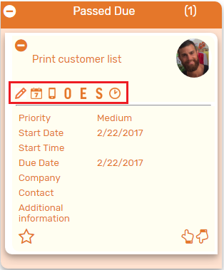**TASK: New Note**Add a new note to the task from the Kanban card.
2. **TASK: New Event**Create a new event from the Kanban card.
3. **TASK: New Phone Call**Create a new phone call from the Kanban card.
4. **TASK: New Opportunity**Create a new opportunity from the Kanban card.
5. **TASK: New Estimate**Create a new estimate from the Kanban card.
6. **TASK: New Sales Order**Create a new salesorder from the Kanban card.
7. **TASK: Enter Time**Add a time tracking record to the task from the Kanban card.

### Kanban – Tasks by Date: Alternative Searches

There are two alternative searches for the *Kanban – Tasks by Date* board.

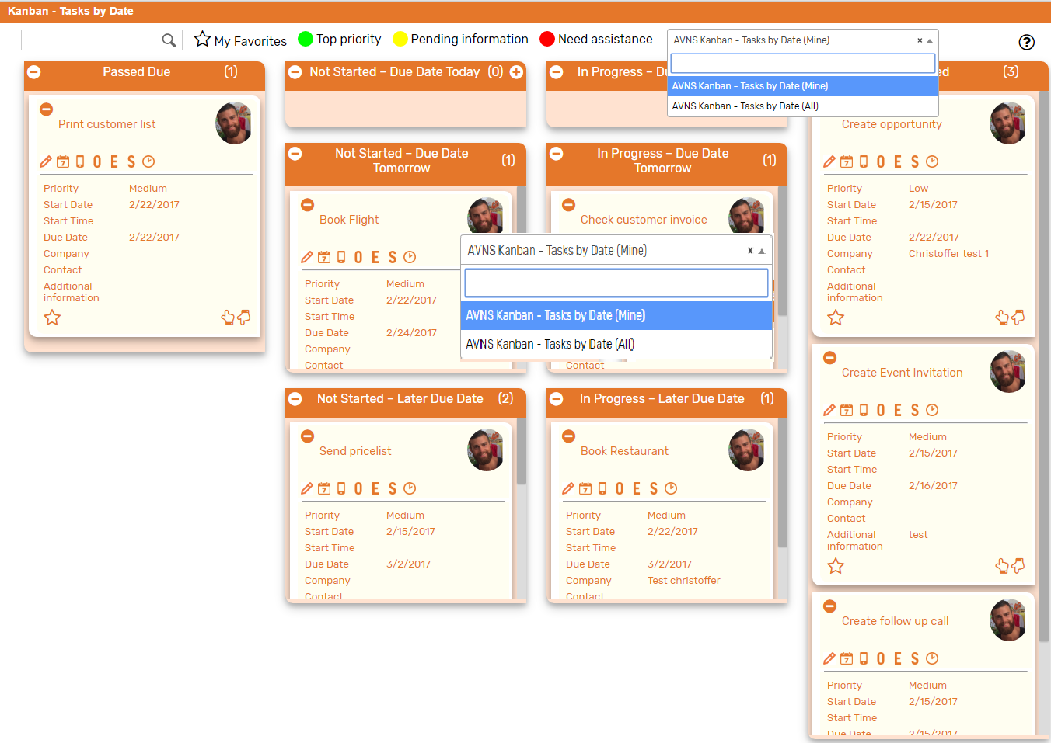

1. **AVNS Kanban – Tasks by Date (All)**This search will display all registered tasks in the *Kanban – Tasks by Date* board.
2. **AVNS Kanban – Tasks by Date (Mine)**This search will display registered tasks where assigned to is *Mine* (current user) in the *Kanban – Tasks by Date* board.

### Kanban – Tasks by Date: Available Colors

There are three colors available for the *Kanban – Tasks by Date* board, which can be used to highlight and filter the Kanban cards (*Top priority // Pending information // Need assistance*). These are defined in the *Color* subtab of the Kanban configuration record.

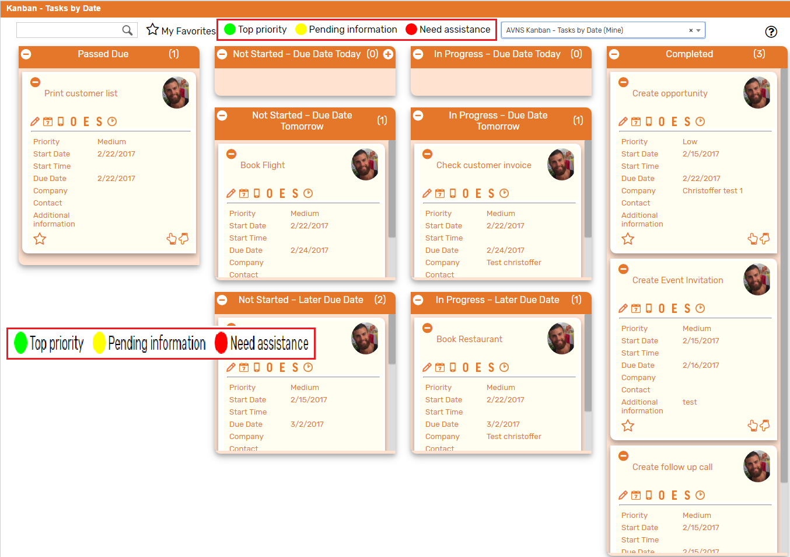

# Kanban – Project Tasks

The prebuilt *Kanban – Project Tasks* provides an overview of registered project tasks in your NetSuite account, with each Kanban column representing the three standard project task status, *Not Started*, *In Progress* and *Completed*. The Column header contains a summary of Remaining work in the columns *Not Started* and *In Progress*. A summary of Actual Work can be found in the columns *In Progress* and *Completed*.

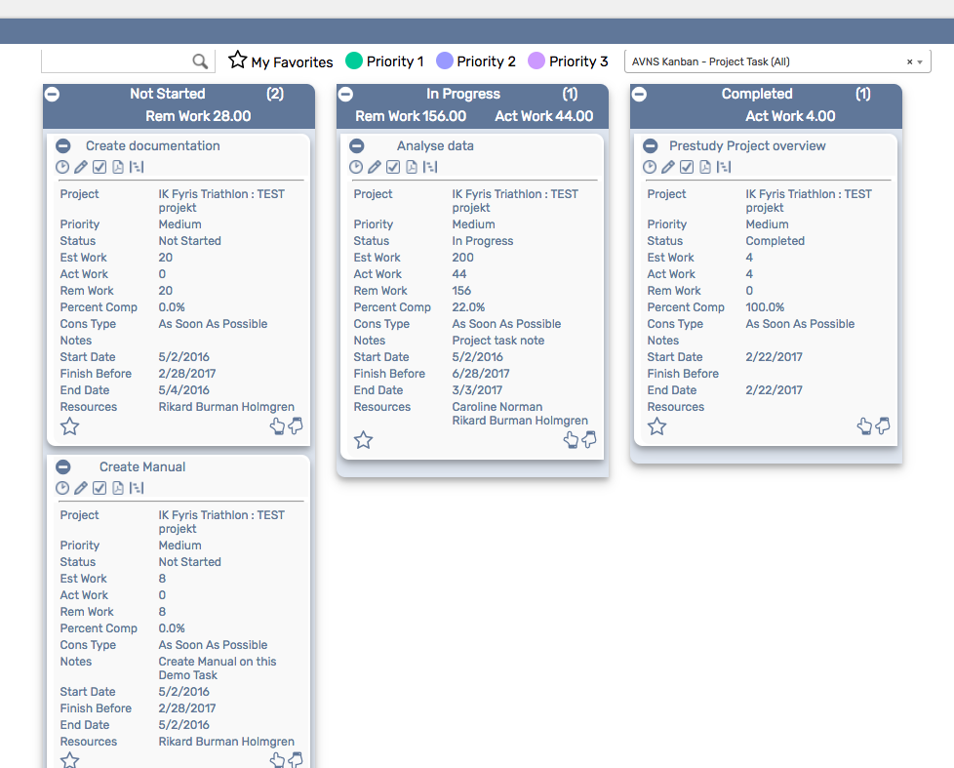  
  
  
Kanban – Project Tasks: Prerequisites

Before using the *Kanban – Project Tasks* board, please make sure the prerequisites listed below are fulfilled in order for the board to function as expected.

1. **Time Tracking**  
   The Kanban Project Tasks Board is configured to use the latest Time Tracking feature in NetSuite. If you have not enabled Time Tracking in your NetSuite setup the Time Tracking Icon in the Kanban board will not work properly. Either you switch on Time Tracking in your NetSuite setup or you remove or reconfigure the Time Tracking card action in the Kanban configuration record. (See User Manual for detailed info)

### Kanban – Project Tasks: Card Moves & Column Actions

The *Kanban – Projects Tasks* board contains three Kanban Columns representing the standard statuses NOT STARTED, IN PROGRESS and COMPLETED. **Currently, in NetSuite standard, it is not possible to add or remove statuses to Project Tasks.** (But with additional custom record fields a more detailed Kanban Board can be achieved. See example at the end of this documentation). Each column has been configured with several Column Actions. Double clicking on any card in the *Kanban – Project Tasks* board will open the project task record in edit mode. In this Kanban board you are allowed to move all Kanban cards to all columns.



1. **NOT STARTED** 
   1. *Card Moves* – Kanban cards in the column NOT STARTED can be moved to all other columns in the Kanban board.
   2. *Column Actions* – when moving a Kanban card to the column NOT STARTED the status of the record represented in the Kanban card will be updated to NOT STARTED.
2. **IN PROGRESS**
   1. *Card Moves* – Kanban cards in the column IN PROGRESS can be moved to all other columns in the Kanban board.
   2. *Column Actions* – when moving a Kanban card to the column IN PROGRESS the status of the record represented in the Kanban card will be updated to IN PROGRESS.
3. **COMPLETED**
   1. *Card Moves* – Kanban cards in the column COMPLETED can be moved to all other columns in the Kanban board.
   2. *Column Actions* – when moving a Kanban card to the column COMPLETED the status of the record represented in the Kanban card will be updated to COMPLETED.

### Kanban – Project Tasks: Available Card Actions

The Kanban cards in the *Kanban – Projects Tasks* board each contains five Card Actions.

1. 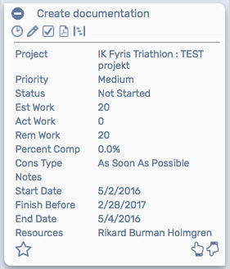**Project Task: Time Tracking**Add a new time tracking to the project task.
2. **Project Task: New Note**Add a new note to the project task.
3. **Project Task: New Project Task**Add a new project task to the parent project record.
4. **Project Task: Project 360 report**Run the Project 360 report for the parent project record.
5. **Project Task: Gantt**Run the Gantt for the parent project record.

### Kanban – Project Tasks: Alternative Searches

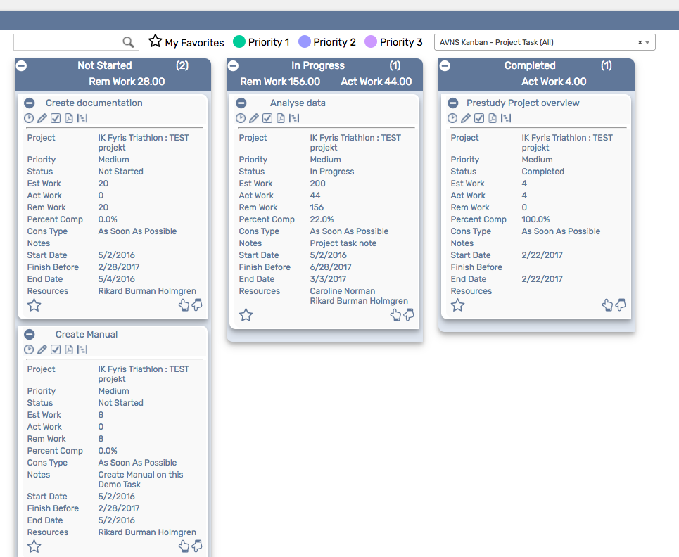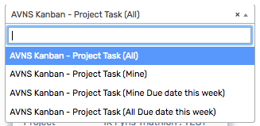There are four alternative searches for the *Kanban – Project Tasks* board.

1. **AVNS Kanban Project Task (All)**This search will display all Project Tasks in your NetSuite system.
2. **AVNS Kanban Project Task (Mine)**This search will display all Projects Tasks where you are an assigned resource to the Project Task.
3. **AVNS Kanban Project Task (All Due date this week)**This search will display all Project Tasks where the field “Finish no later than” is within this week.
4. **AVNS Kanban Project Task (Mine Due date this week)**This search will display all Projects Tasks where you are an assigned resource to the Project Task AND where the field “Finish no later than” is within this week.

Additional searches with other search criteria’s can be added in the Kanban configuration record. (For example, searches for specific projects etc.)

### Kanban – Project Task: Available Colors

There are three colors available for the *Kanban – Project Task* board, which can be used to highlight and filter the Kanban cards (*Priority 1 // Priority 2 // Priority 3*). These are defined in the *Color* subtab of the Kanban configuration record.   
  


### Kanban – Project Tasks: Example of a customized Project Board

In the example below we have added 3 customized field on the Project Task record.

1. *Project Task Substatus* – Which can be a list of values: New, Approved, To do, Doing, Test or Completed.
2. *Project Task type* – Which can be a list of values: Consulting, Development, Fast track, Internal or Bugg
3. *Main responsible* – A field linked to the Employee record.

With these 3 extra fields we can create new columns in the Project Task board. Each column respresent the standard status field combined with the new Substatus field. Image on the Main responsible is picked up from the Employee record.

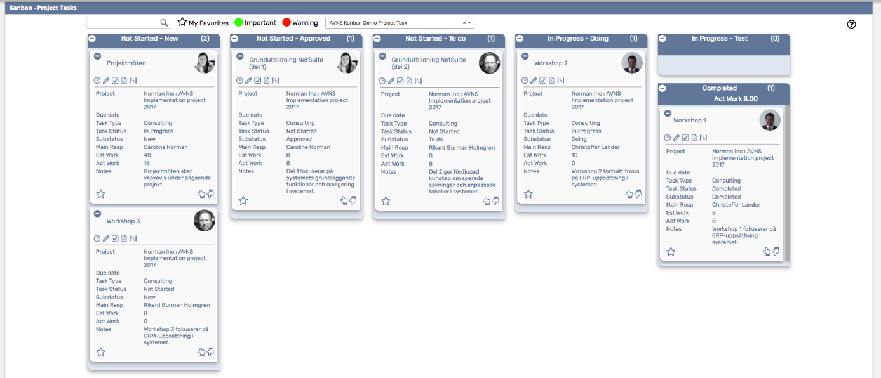

# Kanban – Sales Opportunities

The prebuilt *Kanban – Sales Opportunities* provides an overview of registered opportunities in your NetSuite account, with each Kanban column representing an opportunity status. The last column contains two Kanban columns, stacked on top of each other, one representing opportunities won and the other one opportunities lost.

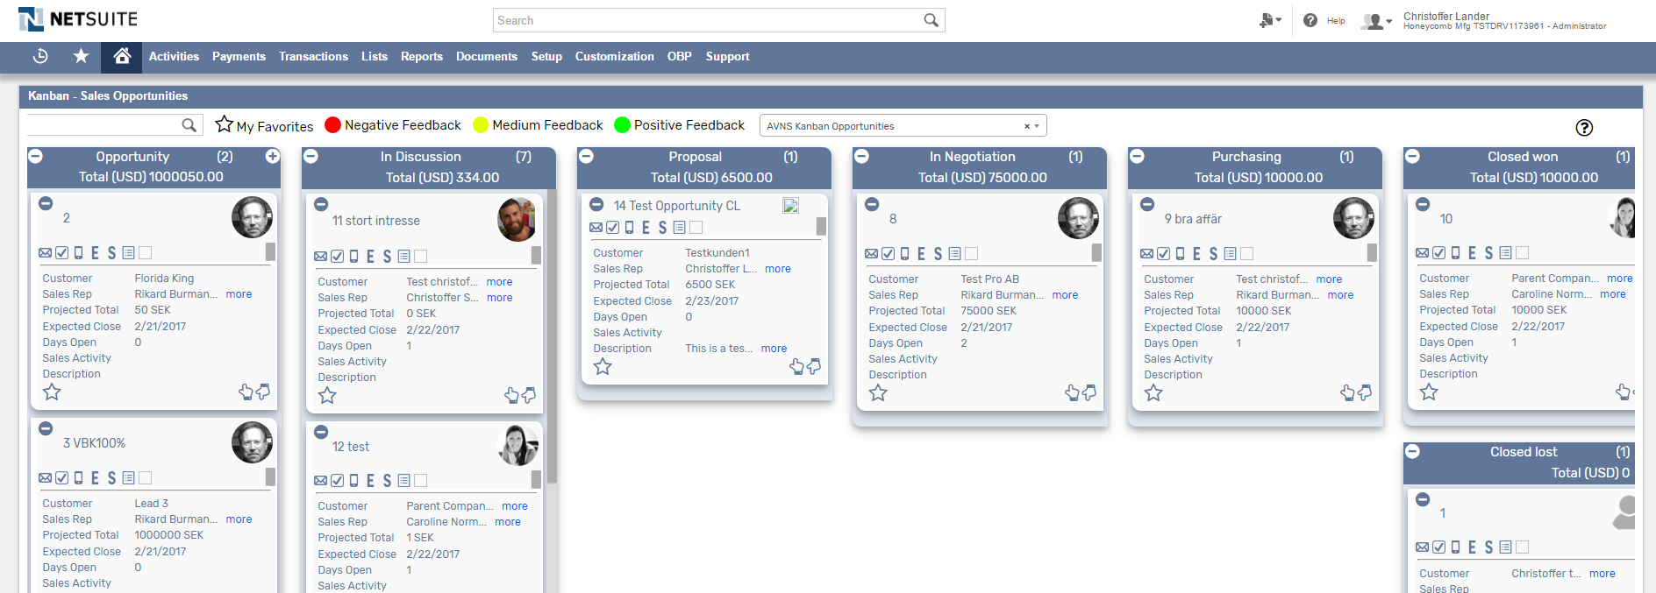

### Kanban – Sales Opportunities: Prerequisites

Before using the *Kanban – Sales opportunities* board, please make sure the prerequisites listed below are fulfilled in order for the board to function as expected.

1. **Customer Status**  
   Since the columns of the prebuilt *Kanban – Sales Opportunities* board are based on NetSuite standard Customer status, it is important that the statuses presented in the board are available in your NetSuite account.   
     
   Navigate to Setup 🡪 Sales 🡪 Customer Statuses (Administrator) to find the list of Customer Statuses available in your NetSuite account. Compare the list from your NetSuite account with the Customer Status list which the prebuilt *Kanban – Sales Opportunities* board is based on (picture below).   
     
     
     
   If the Customer Statuses differ between your NetSuite account and the picture above, you will need to edit the settings of the Kanban Columns for the *Kanban – Sales Opportunity* board.  
   ***Please refer to the section ‘Kanban Columns’ in the ‘Kanban User Guide’***
2. **Sales Rep & Sales Rep Image**  
   Make sure to mark the checkbox ‘Sales Rep’ on the Employee record for all available Sales Reps.   
   If an image has been uploaded to the *Image* field on the Employee record, this image will be displayed on the Kanban card. If no image is available, a predefined profile icon will be displayed instead.

### 

### Kanban – Sales Opportunities: Card Moves & Column Actions

The *Kanban – Sales opportunities* board contains six Kanban Columns. Each column has been configured with one or several Column Actions. Double clicking on any card in the *Kanban – Sales Opportunities* board will open the opportunity record in edit mode.

1. **In Discussion**
   1. *Card Moves* – Kanban cards in the column *In Discussion* can be moved to Identified decision Makers and Closed lost.
   2. *Column Actions* – when moving a Kanban card to the column *In Discussion* the status of the record represented in the Kanban card will be updated to *In Discussion.*
   3. *Add Card* – it is possible to add a Kanban card (a new record) from the column *In Discussion* by clicking on the + icon in the top right corner of the column.
2. **Identified Decision Makers**
   1. *Card Moves* – Kanban cards in the column *Identified Decision Makers* can be moved to In discussion and Closed lost.
   2. *Column Actions* – when moving a Kanban card to the column *Identified Decision Maker* the status of the record represented in the Kanban card will be updated to *Identified Decision Makers*.
3. **Proposal**
   1. *Card Moves* – Kanban cards in the column *Proposal* can be moved to In Negotiation and Purchasing.
   2. *Column Actions* – when moving a Kanban card to the column *Proposal* the status of the record represented in the Kanban card will be updated to *Proposal.* This is not possible from lower levels but to move a card here you need to create an estimate. Netsuite will automatically set status to *Proposal* on your opportunity. You can also manually do this to force card movement.
4. **In Negotiation**
   1. *Card Moves* – Kanban cards in the column *In Negotiation* can be move to proposal or purchasing.
   2. *Column Actions* – when moving a Kanban card to the column *In Negotiation* the status of the record represented in the Kanban card will be updated to *In Negotiation*.
5. **Purchasing**
   1. *Card Moves* – Kanban cards in the column *Purchasing* can be moved to proposal or in negotiation.
   2. *Column Actions* – when moving a Kanban card to the column *Purchasing* the status of the record represented in the Kanban card will be updated to *Purchasing*.
6. **Closed Won**
   1. *Card Moves* – Kanban cards in the column *Closed Won* can´t be moved. In order move cards here you need to create a Sales order.
   2. *Column Actions* – when moving a Kanban card to the column *Closed Won* the status of the record represented in the Kanban card will be updated to *Closed Won*.
7. **Closed Lost**
   1. *Card Moves* – Kanban cards in the column *Closed Lost* can be moved to all other columns in the Kanban board.
   2. *Column Actions* – when moving a Kanban card to the column *Closed Lost* the status of the record represented in the Kanban card will be updated to *Closed* Lost*.*

### Kanban – Sales Opportunities: Available Card Actions

The Kanban cards in the *Kanban – Sales Opportunities* board each contains six Card Actions.

1. 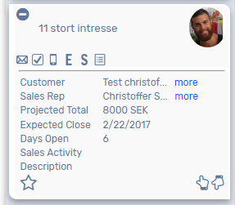**New Email**Add a new email.
2. **New Task**Add a new task.
3. **New Phone Call**Add a new phone call.
4. **New Estimate**Create an estimate from your opportunity.
5. **New Sales Order**Create a sales order from your opportunity.
6. **Show Activity**Show a list of all activities.

### Kanban – Sales Opportunities: Alternative Searches

There are three alternative searches for the *Kanban – Sales opportunities* board.

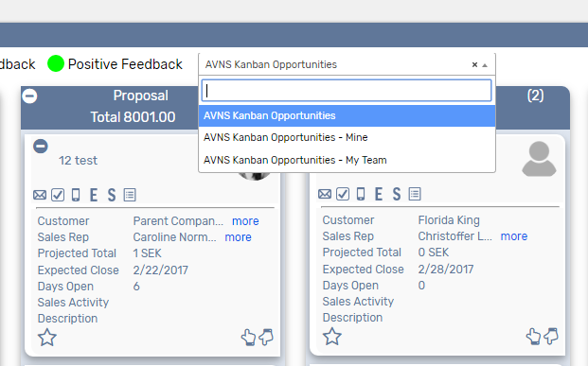

1. **AVNS Kanban Opportunities**

This search will display all registered opportunities.

1. **AVNS Kanban Opportunities - Mine**This search will display opportunities registered to me.
2. **AVNS Kanban Opportunities – My Team**This search will display opportunities registered to a member of my team.

### Kanban – Sales Opportunities: Available Colors

There are three colors available for the *Kanban – Sales Opportunities* board, which can be used to highlight and filter the Kanban cards (Negative / Medium / Positive feedback). These are defined in the *Color* subtab of the Kanban configuration record. 

# Kanban – Estimates

The prebuilt *Kanban – Estimates* provides an overview of registered estimates in your NetSuite account, with each Kanban column representing an estimate status. The last column contains two Kanban columns, stacked on top of each other, one representing estimates won and the other one estimates lost.

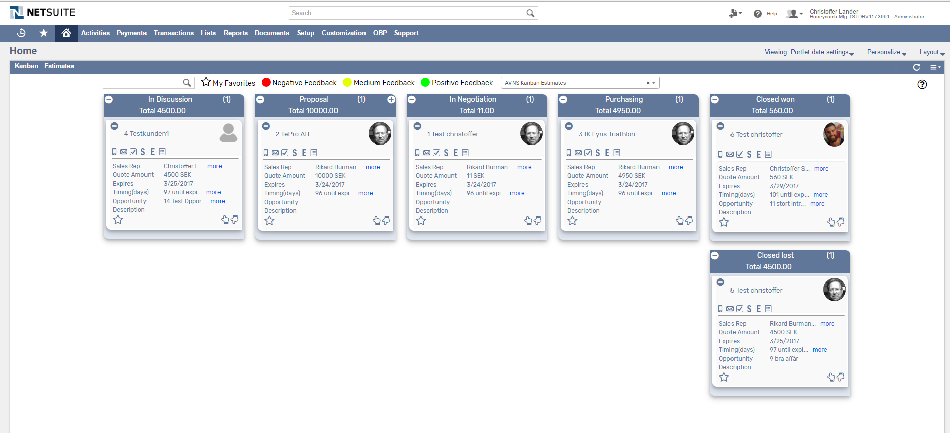

### Kanban – Estimates: Prerequisites

Before using the *Kanban – Estimates* board, please make sure the prerequisites listed below are fulfilled in order for the board to function as expected.

1. **Customer Status**  
   Since the columns of the prebuilt *Kanban – Estimates* board are based on NetSuite standard Customer status, it is important that the statuses presented in the board are available in your NetSuite account.   
     
   Navigate to Setup 🡪 Sales 🡪 Customer Statuses (Administrator) to find the list of Customer Statuses available in your NetSuite account. Compare the list from your NetSuite account with the Customer Status list which the prebuilt *Kanban – Estimates* board is based on (picture below).   
     
     
     
   If the Customer Statuses differ between your NetSuite account and the picture above, you will need to edit the settings of the Kanban Columns for the *Kanban – Estimates* board.  
   ***Please refer to the section ‘Kanban Columns’ in the ‘Kanban User Guide’***
2. **Sales Rep & Sales Rep Image**  
   Make sure to mark the checkbox ‘Sales Rep’ on the Employee record for all available Sales Reps.   
   If an image has been uploaded to the *Image* field on the Employee record, this image will be displayed on the Kanban card. If no image is available, a predefined profile icon will be displayed instead.

### 

### Kanban – Estimates: Card Moves & Column Actions

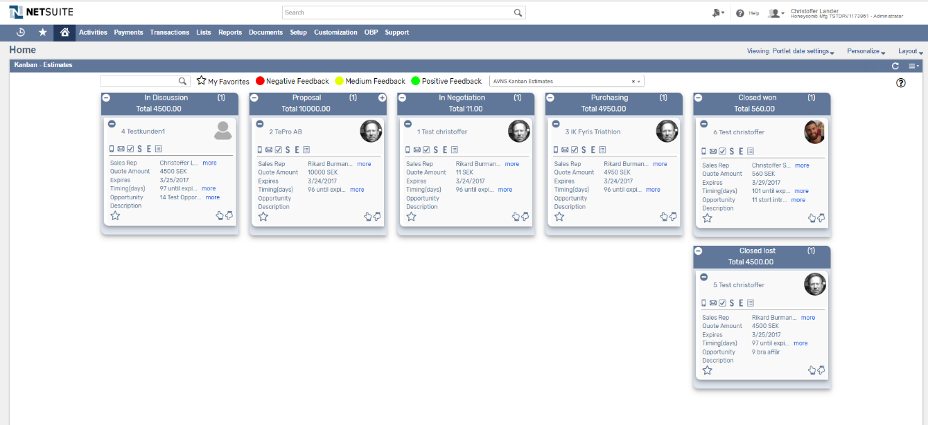The *Kanban – Estimates* board contains five Kanban Columns. Each column has been configured with one or several Column Actions. Double clicking on any card in the *Kanban – Estimates* board will open the estimate record in edit mode.

1. **In Discussion**
   1. *Card Moves* – Kanban cards in the column *In Discussion* can be moved to all other columns in the Kanban board, except Closed Won.
   2. *Column Actions* – when moving a Kanban card to the column *In Discussion* the status of the record represented in the Kanban card will be updated to *Estimate* – *In Discussion.*
2. **Proposal**
   1. *Card Moves* – Kanban cards in the column *Proposal* can be moved to all other columns in the Kanban board, except Closed Won.
   2. *Column Actions* – when moving a Kanban card to the column *Proposal* the status of the record represented in the Kanban card will be updated to *Estimate – Proposal.*
3. **In Negotiation**
   1. *Card Moves* – Kanban cards in the column *In Negotiation* can be moved to all other columns in the Kanban board, except Closed Won.
   2. *Column Actions* – when moving a Kanban card to the column *In Negotiation* the status of the record represented in the Kanban card will be updated to *Estimate – In Negotiation*.
4. **Purchasing**
   1. *Card Moves* – Kanban cards in the column *Purchasing* can be moved to all other columns in the Kanban board, except Closed Won.
   2. *Column Actions* – when moving a Kanban card to the column *purchasing* the status of the record represented in the Kanban card will be updated to *Estimate – Purchasing*.
5. **Closed Won**
   1. *Card Moves* – Kanban cards in the column *Closed Won* can be moved to all other columns in the Kanban board. To move card here a Sales Order needs to be created.
   2. *Column Actions* – when moving a Kanban card to the column *Closed Won* the status of the record represented in the Kanban card will be updated to *Estimate – Closed Won*.
6. **Closed Lost**
   1. *Card Moves* – Kanban cards in the column *Closed Lost* can be moved to all other columns in the Kanban board, except Closed Won.
   2. *Column Actions* – when moving a Kanban card to the column *Closed Lost* the status of the record represented in the Kanban card will be updated to *Closed* *Lost.*

### Kanban – Estimates: Available Card Actions

The Kanban cards in the *Kanban – Estimates* board each contains six Card Actions.

1. 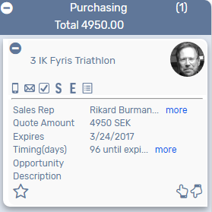**New Email**Add a new email.
2. **New Task**Add a new task.
3. **New Phone Call**Add a new phone call.
4. **Copy Estimate**

Copy existing estimate.

1. **New Sales Order**Create a sales order from the estimate.
2. **Show Activity**Show a list of all activities related to the estimate.

### Kanban – Estimate: Alternative Searches

There are three alternative searches for the *Kanban – Estimate* board.  
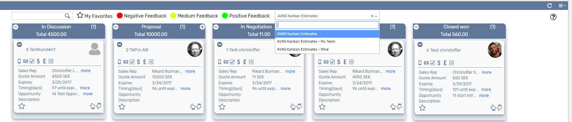

1. **AVNS Kanban Estimate**Display all estimates.
2. **AVNS Kanban Prospect – My Team**Display estimates with sales rep any of my team.
3. **AVNS Kanban Prospect - Mine**Display estimates with you as a sales rep.

### Kanban – Estimates: Available Colors

There are three colors available for the *Kanban – Estimates* board, which can be used to highlight and filter the Kanban cards (Negative / Medium / Positive feedback). These are defined in the *Color* subtab of the Kanban configuration record. 

# Kanban – Support

The prebuilt *Kanban – Support* provides an overview of registered support cases in your NetSuite account, with each Kanban column representing a case status in the support flow.

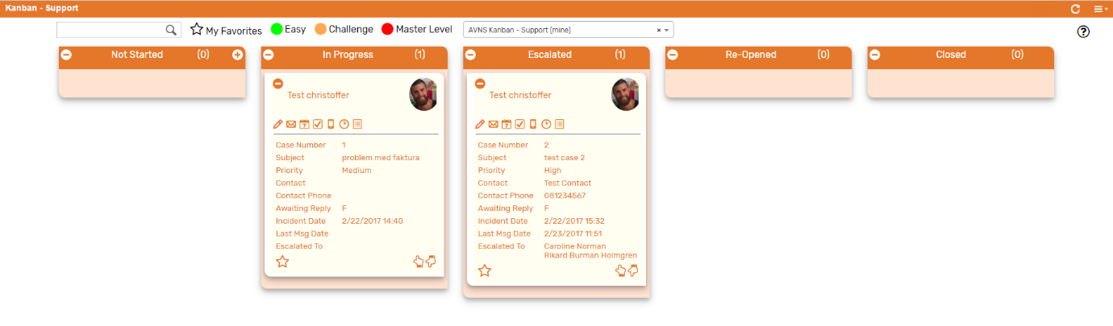

### Kanban – Support: Prerequisites

Before using the *Kanban – Support*, please make sure the prerequisites listed below are fulfilled in order for the board to function as expected.

1. **Support Rep & Sales Rep Image**  
   Make sure to mark the checkbox ‘Support Rep’ on the Employee record for all available Support Reps.   
   If an image has been uploaded to the *Image* field on the Employee record, this image will be displayed on the Kanban card. If no image is available, a predefined profile icon will be displayed instead.

### 

### Kanban – Support: Card Moves & Column Actions

The *Kanban – Support* board contains five Kanban Columns. Each column has been configured with one or several Column Actions. Double clicking on any card in the *Kanban – Support* board will open the case record in edit mode.

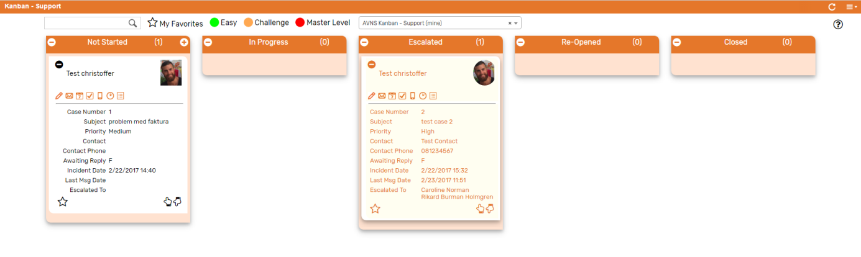

1. **Not Started**
   1. *Card Moves* – Kanban cards in the column *Not Started* can be moved to all other columns in the Kanban board except Re-Opened.
   2. *Column Actions* – when moving a Kanban card to the column *Not Started* the status of the record represented in the Kanban card will be updated to *Not Started*.
2. **In Progress**
   1. *Card Moves* – Kanban cards in the column *In Progress* can be moved to all other columns in the Kanban board except Re-Opened.
   2. *Column Actions* – when moving a Kanban card to the column *In Progress* the status of the record represented in the Kanban card will be updated to *In Progress and the* Assigned To *will be updated to @MySELF@* (Current User).
   3. *Add Card* –It is possible to add a Kanban card (a new record) from the column *Not Started* by clicking on the + icon in the top right corner of the column.
3. **Escalated**
   1. *Card Moves* – Kanban cards in the column *Escalated* can be moved to all other columns in the Kanban board except Re-Opened.
   2. *Column Actions* – when moving a Kanban card to the column *Escalated* the status of the record represented in the Kanban card will be updated to *Escalated*.
4. **Re-Opened**
   1. *Card Moves* – Kanban cards in the column *Re-Opened* can be moved to all other columns in the Kanban board.
   2. *Column Actions* – when moving a Kanban card to the column *Re-Opened* the status of the record represented in the Kanban card will be updated to *Re-Opened*.
5. **Closed**
   1. *Card Moves* – Kanban cards in the column *Closed* can be moved to all other columns in the Kanban board.
   2. *Column Actions* – when moving a Kanban card to the column *Closed* the status of the record represented in the Kanban card will be updated to *Closed*.

### Kanban – Support: Available Card Actions

The Kanban cards in the *Kanban – Support* board each contains seven Card Actions.

1. 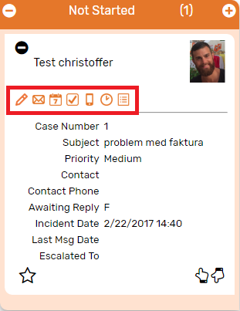**Support: New Note**Add a new note to the case from the Kanban card.
2. **Support: Send Email**

Create an email message and send directly from the Kanban card.

1. **Support: New Event**Add a new event to the case from the Kanban card.
2. **Support: New Task**Add a new task to the case from the Kanban card.
3. **Support: New Phone Call**Add a new phone call to the case from the Kanban card.
4. **Support: Enter Time**Add a time tracking record to the case from the Kanban card.
5. **Support: View History**Show historical messages for the case from the Kanban card

### Kanban – Support: Alternative Searches

There are two alternative searches for the *Kanban – Support* board.  
  
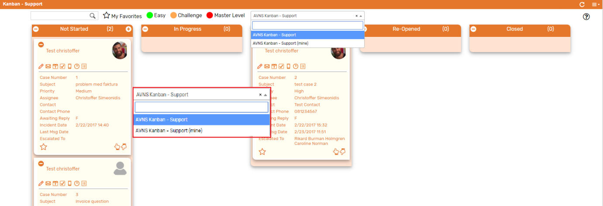

1. **AVNS Kanban – Support**This search will display all registered cases in the *Kanban – Support* board.
2. **AVNS Kanban – Support (mine)**This search will display registered cases where assigned to is *Mine* (current user) in the *Kanban – Support* board.

### Kanban – Support: Available Colors

There are three colors available for the *Kanban – Support*, which can be used to highlight and filter the Kanban cards (*Easy // Challenge // Master Level*). These are defined in the *Color* subtab of the Kanban configuration record.

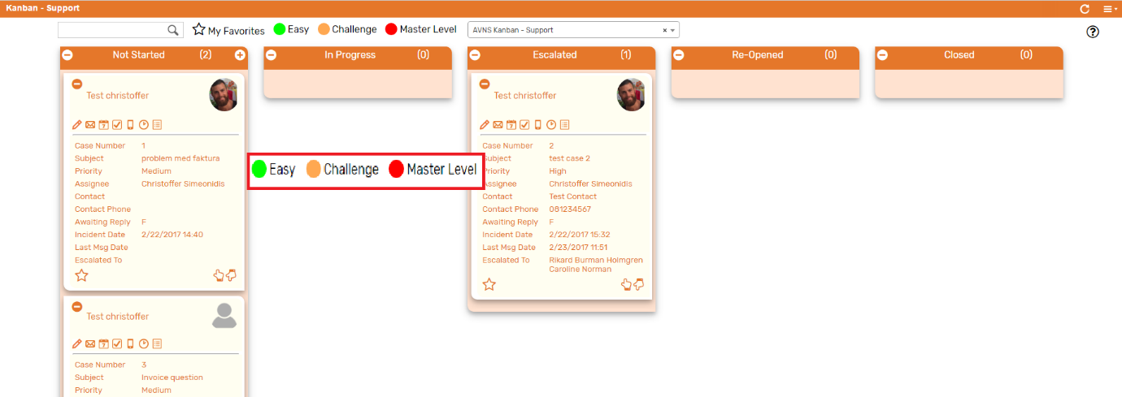

# Sales Team Configuration

If Sales Team is activated in your NetSuite account, the prebuilt Kanban boards including the Sales Rep field need additional configurations in order to function as expected. Use the standard Administration role for the following configuration.

### Create Entity Field on the Employee Record

1. **AVNS Kanban – Support**This search will display all registered cases in the *Kanban – Support* board.

**1.** Create a new Entity Field on the Employee record  
Create a new Integer number field on the Employee record. This field will hold the internal ID of the employee’s default sales team. Enter the appropriate internal ID manually on each sales rep employee record.  
  
BILD

Find the appropriate internal ID by activating internal ID in Set Preferences and navigate to the list of available sales teams in your NetSuite account (Setup🡪 Sales🡪 Sales Teams).  
  
BILD  
  
**2.** Include Sales Team members in the saved search  
In the saved search associated with the Kanban board, add the field Sales Team Members in the result tab. Make sure the Custom Label has the following syntax: *fieldid{label:fieldid}*

BILD

To display the Sales Team Members in the Kanban card, makes sure to also include the field with a Custom Label as shown in the image below:  
  
BILD

**3.** Update Sales Team with Column Action  
Include a Kanban Column Action to update the sales team on the entity record. Set the column action fields to the following values:   
  
*Field* = “salesgroup” (this is the internal id for the Sales Team field on the entity record)  
*Value* = fieldid (